**CO24497: PROGRAMMING PRACTICES**

**Lab Journals**



**Session 2023-2024**

**Submitted To: Submitted By:**

**Surendra Gupta Mohan Manjhi**

**Ms. Mamta Gupta 0801CS233D05**

**Ms. Saloni Jain**

**Ms. Nikita Tiwari**

**Computer Engineering Department**

**SHRI G. S. INSTITUTE OF TECHNOLOGY & SCIENCE, INDORE**

|  |  |  |  |  |
| --- | --- | --- | --- | --- |
| **S. No.** | **Assignment Name** | **Submission Date** | **Page. No.** | **Remark** |
| **1** | **Programming Assignments**   1. Write a C program to print the following characters in reverse. 2. Write a C program to compute the perimeter and area of a rectangle with a height and width. 3. Write a C program to read an amount (integer value) and break the amount into the smallest possible number of bank notes. 4. Write a C program that read 5 numbers and sum of all odd values between them. 5. Write a C program that finds all the divisors of an integer. 6. Write a C program that swaps two numbers without using a third variable. 7. Write a C program to reverse and print a given number. 8. Write a C program to display the sum of series 1 + 1/2 + 1/3 + ………. + 1/n. 9. WAP to find number is even or odd? 10. WAP to covert decimal to binary. 11. WAP to reverse a string. 12. 2^15 = 32768 and the sum of its digits is 3 + 2 + 7 + 6 + 8 = 26. 13. Write a Program to print Binary Equivalent of an Integer using Recursion. 14. Write a program to calculate power of any number. 15. Write a program to print if a number is a palindrome number or not. 16. Write a program to print Armstrong series. 17. Write a program to remove the all-duplicates numbers from the given array. 18. WAP to print diamond pattern in c. 19. Write a program in C to sort elements of an array in ascending order. 20. Write a program to check if a year is leap year or not. 21. Write a program to print Fibonacci series. 22. Write a C program to find the largest element in an array. 23. WAP to find the length of a string without using strlen() function. 24. Write a program to print Factorial of a number using Recursion? 25. Write a c program to print multiplication of 2 matrics. |  | **4-30** |  |
| **2** | **Skill based activities**   1. Coding Standards 2. Version controlling 3. Python 4. Profiling 5. Debugging 6. LaTex 7. Infrastrutures 8. Linux |  | **31-95** |  |
| **3** | **Mini Project**   1. Overview 2. Code 3. Latex |  | **96-103** |  |

**25 Programming Practice Questions**

**In C**

**25 Programming Practice Questions**

1. Write a C program to print the following characters in reverse.

Test Characters: 'X', 'M', 'L'

Expected Output:

The reverse of XML is LMX

#include <stdio.h>

int main()

{

// Declare and initialize character variables

char char1 = 'X';

char char2 = 'M';

char char3 = 'L';

// Print the original and reversed characters

printf("The reverse of %c%c%c is %c%c%c\n",

char1, char2, char3,

char3, char2, char1);

return(0);

}

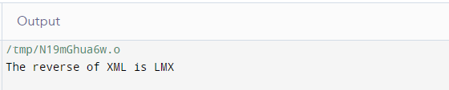

2. Write a C program to compute the perimeter and area of a rectangle with a height and width.

#include <stdio.h>

int main() {

int width,height,area,perimeter;

printf("Enter the height of rectangle");

scanf("%d",&height);

printf("Enter the width of rectangle");

scanf("%d",&widtht);

perimeter = 2*(height + width);

printf("Perimeter of the rectangle = %d inches\n", perimeter);

area = height * width;

printf("Area of the rectangle = %d square inches\n", area);

return(0);

}

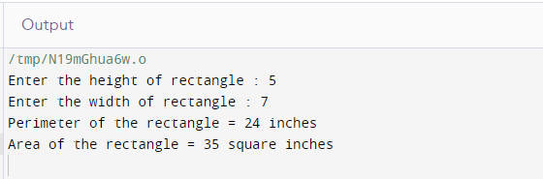

Q3. Write a C program to read an amount (integer value) and break the amount into the smallest possible number of bank notes.

Test Data :

Input the amount: 375

Expected Output:

There are:

3 Note(s) of 100.00

1 Note(s) of 50.00

1 Note(s) of 20.00

0 Note(s) of 10.00

1 Note(s) of 5.00

0 Note(s) of 2.00

0 Note(s) of 1.00

#include <stdio.h>

int main() {

int amt, total;

printf("Input the amount: ");

scanf("%d",&amt);

total = (int)amt/100;

printf("There are:\n");

printf("%d Note(s) of 100.00\n", total);

amt = amt-(total*100);

total = (int)amt/50;

printf("%d Note(s) of 50.00\n", total);

amt = amt-(total*50);

total = (int)amt/20;

printf("%d Note(s) of 20.00\n", total);

amt = amt-(total*20);

total = (int)amt/10;

printf("%d Note(s) of 10.00\n", total);

amt = amt-(total*10);

total = (int)amt/5;

printf("%d Note(s) of 5.00\n", total);

amt = amt-(total*5);

total = (int)amt/2;

printf("%d Note(s) of 2.00\n", total);

amt = amt-(total*2);

total = (int)amt/1;

printf("%d Note(s) of 1.00\n", total);

return 0;

}

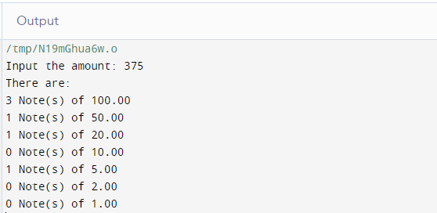

4. Write a C program that read 5 numbers and sum of all odd values between them.

#include <stdio.h>

int main() {

int j, numbers[5], total=0;

printf("\nInput the first number: ");

scanf("%d", &numbers[0]);

printf("\nInput the second number: ");

scanf("%d", &numbers[1]);

printf("\nInput the third number: ");

scanf("%d", &numbers[2]);

printf("\nInput the fourth number: ");

scanf("%d", &numbers[3]);

printf("\nInput the fifth number: ");

scanf("%d", &numbers[4]);

for(j = 0; j < 5; j++) {

if((numbers[j]%2) != 0)

{

total += numbers[j];

}

}

printf("\nSum of all odd values: %d", total);

return 0;

}

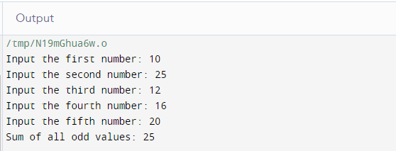

5. Write a C program that finds all the divisors of an integer.

Test Data: Input an integer: 45

Expected Output: All the divisor of 45 are : 1 3 5 9 15 45

#include <stdio.h>

int main() {

int x, i;

// Get an integer input from the user

printf("\nInput an integer: ");

scanf("%d", &x);

// Print all the divisors of x

printf("All the divisors of %d are: ", x);

for(i = 1; i <= x; i++) {

if((x%i) == 0){

printf("\n%d", i);

printf("\n");

}

}

return 0;

}

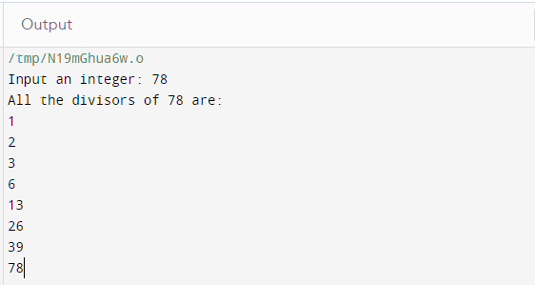

6. Write a C program that swaps two numbers without using a third variable.

Input value for x & y:

Before swapping the value of x & y: 5 7

After swapping the value of x & y: 7 5

#include<stdio.h>

int main() {

int x, y;

// Prompt user to input values for x and y

printf("Input value for x & y: \n");

scanf("%d%d",&x,&y);

// Display the values of x and y before swapping

printf("Before swapping the value of x & y: %d %d",x,y);

// Swap the values of x and y using arithmetic operations

x = x + y;

y = x - y;

x = x - y;

// Display the values of x and y after swapping

printf("\nAfter swapping the value of x & y: %d %d",x,y);

return 0;

}

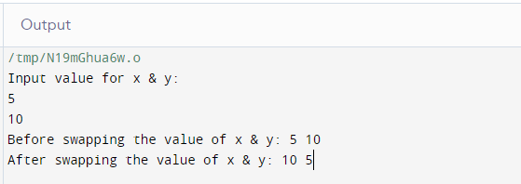

7. Write a C program to reverse and print a given number.

Input a number:

The original number = 234

The reverse of the said number = 432

#include<stdio.h>

int main() {

int num, x, r_num = 0;

printf("Input a number: ");

scanf("%d", &num);

printf("\nThe original number = %d", num);

// Reverse the digits of the number

while (num >= 1) {

x = num % 10;

r_num = r_num * 10 + x;

num = num / 10;

}

// Print the reverse of the number

printf("\nThe reverse of the said number = %d", r_num);

return 0;

}

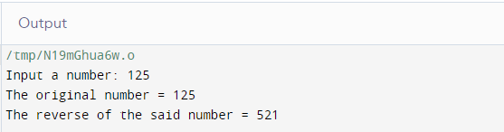

8. Write a C program to display the sum of series 1 + 1/2 + 1/3 + ………. + 1/n.

#include<stdio.h>

int main() {

int num, i, sum = 0;

printf("Input any number: ");

scanf("%d", &num);

printf("1 + ");

for(i = 2; i <= num - 1; i++)

printf(" 1/%d +", i);

for(i = 1; i <= num; i++)

sum = sum + i;

printf(" 1/%d", num);

printf("\nSum = 1/%d", sum + 1/num);

return 0;

}

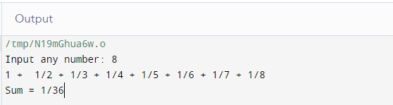

9. WAP to find number is even or odd?

#include <stdio.h>

int main() {

int value;

scanf("%d",&value);

if(value%2==0){

printf("Even");

}else{

printf("Odd");

}

return 0;

}

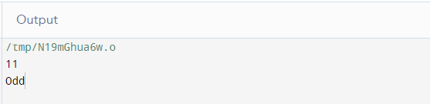

10. WAP to covert decimal to binary.

#include<stdio.h>

int main(){

int a[10],n,i;

printf("Enter the number to convert: ");

scanf("%d",&n);

for(i=0;n>0;i++)

{

a[i]=n%2;

n=n/2;

}

printf("\nBinary of Given Number is=");

for(i=i-1;i>=0;i--)

{

printf("%d",a[i]);

}

return 0;

}

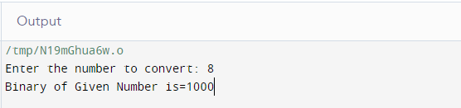

11. WAP to reverse a string.

# include <stdio.h>

void reverse(char *str)

{

if (*str)

{

reverse(str + 1);

printf("%c", *str);

}

}

int main()

{

char a[] = "NAHOM";

reverse(a);

return 0;

}

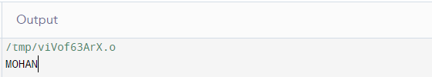

12. 2^15 = 32768 and the sum of its digits is 3 + 2 + 7 + 6 + 8 = 26.

#include <stdio.h>

#include <math.h>

int main()

{

int n;

printf("Enter the value of 2^x ");

scanf("%d",&n);

int b=pow(2,n);

printf(" %d\n",b);

printf("Sum of all digit is %d ", getSum(b));

return 0;

}

int getSum(int b)

{

int sum = 0;

while (b != 0) {

sum = sum + b % 10;

b = b / 10;

}

return sum;

}

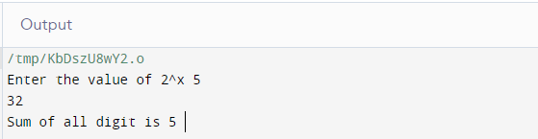

13. Write a Program to print Binary Equivalent of an Integer using Recursion.

#include <stdio.h>

int binary_conversion(int);

int main()

{

int num, bin;

printf("Enter a decimal number: ");

scanf("%d", &num);

bin = binary_conversion(num);

printf("The binary equivalent of %d is %d\n", num, bin);

}

int binary_conversion(int num)

{

if (num == 0)

{

return 0;

}

else

{

return (num % 2) + 10 * binary_conversion(num / 2);

}

}

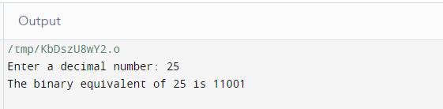

14. Write a program to calculate power of any number.

#include <stdio.h>

long power(int x, unsigned n)

{

long long pow = 1;

for (int i = 0; i < n; i++) {

pow = pow * x;

}

return pow;

}

int main(void)

{

int x;

printf("Enter value of x:\n");

scanf("%d",&x);

unsigned n;

printf("Enter value of n:\n");

scanf("%d",&n);

int result = power(x, n);

printf("%d", result);

return 0;

}

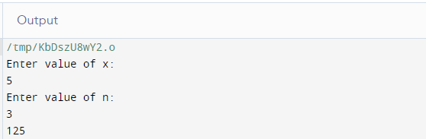

15. Write a program to print if a number is a palindrome number or not.

#include <stdio.h>

int main()

{

int original_number;

printf("Enter value:\n");

scanf("%d",&original_number);

int reversed = 0;

int num = original_number;

while (num != 0) {

int r = num % 10;

reversed = reversed * 10 + r;

num /= 10;

}

if (original_number == reversed) {

printf(" Given number %d is a palindrome number",

original_number);

}

else {

printf(

" Given number %d is not a palindrome number",

original_number);

}

return 0;

}

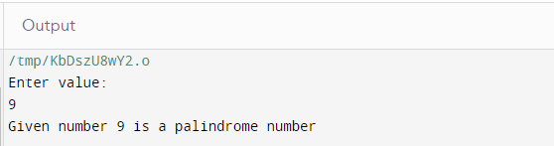

16. Write a program to print Armstrong series.

#include <stdio.h>

int main()

{

int n;

scanf("%d",&n);

int temp = n;

int p = 0;

while (n > 0) {

int rem = n % 10;

p = (p) + (rem * rem * rem);

n = n / 10;

}

if (temp == p) {

printf("Yes. It is Armstrong No.");

}

else {

printf("No. It is not an Armstrong No.");

}

return 0;

}

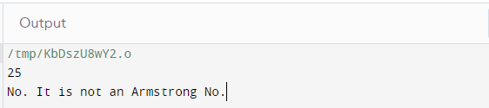

17. Write a program to remove the all-duplicates numbers from the given array.

#include <stdio.h>

int main()

{

int n, count = 0;

printf("Enter number of elements in the array: ");

scanf("%d", &n);

int arr[n], temp[n];

if(n==0){

printf("No element inside the array.");

exit(0);

}

printf("Enter elements in the array: ");

for (int i = 0; i < n; i++){

scanf("%d", &arr[i]);

}

printf("\nArray Before Removing Duplicates: ");

for (int i = 0; i < n; i++)

printf("%d ", arr[i]);

for (int i = 0; i < n; i++){

int j;

for (j = 0; j < count; j++){

if (arr[i] == temp[j])

break;

}

if (j == count){

temp[count] = arr[i];

count++;

}

}

printf("\nArray After Removing Duplicates: ");

for (int i = 0; i < count; i++)

printf("%d ", temp[i]);

return 0;

}

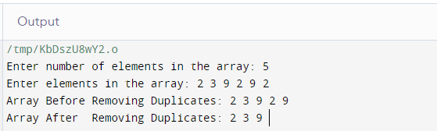

18. WAP to print diamond pattern in c.

#include <stdio.h>

int main()

{

int n, c, k;

printf("Enter number of rows\n");

scanf("%d", &n);

for (k = 1; k <= n; k++)

{

for (c = 1; c <= n-k; c++)

printf(" ");

for (c = 1; c <= 2*k-1; c++)

printf("*");

printf("\n");

}

for (k = 1; k <= n - 1; k++)

{

for (c = 1; c <= k; c++)

printf(" ");

for (c = 1 ; c <= 2*(n-k)-1; c++)

printf("*");

printf("\n");

}

return 0;

}

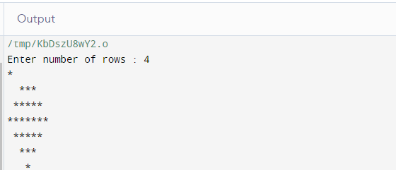

1. Write a program in C to sort elements of an array in ascending order.

Test Data :

Input the size of array : 5

Input 5 elements in the array :

element - 0 : 2

element - 1 : 7

element - 2 : 4

element - 3 : 5

element - 4 : 9

Expected Output :

Elements of array in sorted ascending order:

2 4 5 7 9

#include <stdio.h>

void main(){

int arr1[100];

int n, i, j, tmp;

printf("\n\nsort elements of array in ascending order :\n ");

printf("Input the size of array : ");

scanf("%d", &n);

printf("Input %d elements in the array :\n",n);

for(i=0;i<n;i++){

printf("element - %d : ",i);

scanf("%d",&arr1[i]);

}

for(i=0; i<n; i++){

for(j=i+1; j<n; j++){

if(arr1[j] <arr1[i]){

tmp = arr1[i];

arr1[i] = arr1[j];

arr1[j] = tmp;

}

}

}

printf("\nElements of array in sorted ascending order:\n");

for(i=0; i<n; i++){

printf("%d ", arr1[i]);

}

printf("\n\n");

}

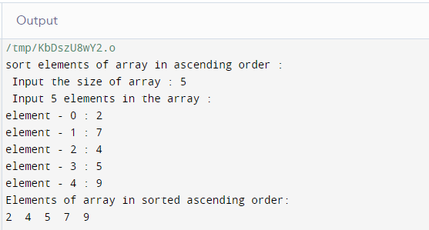

20. Write a program to check if a year is leap year or not.

#include <stdio.h>

int main() {

int year;

printf("Enter a year: ");

scanf("%d", &year);

if (year % 400 == 0) {

printf("%d is a leap year.", year);

}

else if (year % 100 == 0) {

printf("%d is not a leap year.", year);

}

else if (year % 4 == 0) {

printf("%d is a leap year.", year);

}

else {

printf("%d is not a leap year.", year);

}

return 0;

}

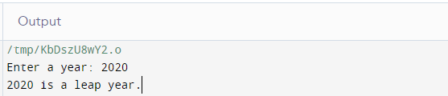

21. Write a program to print Fibonacci series.

#include <stdio.h>

int prev1 = 1;

int prev2 = 0;

void fib(int n)

{

if (n < 3) {

return;

}

int fn = prev1 + prev2;

prev2 = prev1;

prev1 = fn;

printf("%d ", fn);

return fib(n - 1);

}

void printFib(int n)

{

if (n < 1) {

printf("Invalid number of terms\n");

}

else if (n == 1) {

printf("%d ", 0);

}

else if (n == 2) {

printf("%d %d", 0, 1);

}

else {

printf("%d %d ", 0, 1);

fib(n);

}

return;

}

int main()

{

int n;

printf("Enter value:\n");

scanf("%d",&n);

printFib(n);

return 0;

}

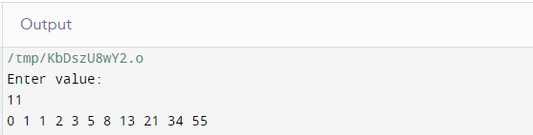

22. Write a C program to find the largest element in an array.

#include <stdio.h>

int largest(int arr[], int n)

{

int i;

int max = arr[0];

for (i = 1; i < n; i++)

if (arr[i] > max)

max = arr[i];

return max;

}

int main()

{

int arr[] = { 10, 324, 45, 90, 9808 };

int n = sizeof(arr) / sizeof(arr[0]);

printf("Largest in given array is %d", largest(arr, n));

return 0;

}

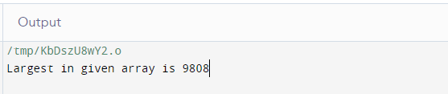

23. WAP to find the length of a string without using strlen() function.

#include <stdio.h>

int main() {

char s[] = "Hello my name is Mohan";

int i;

for (i = 0; s[i] != '\0'; ++i);

printf("Length of the string: %d", i);

return 0;

}

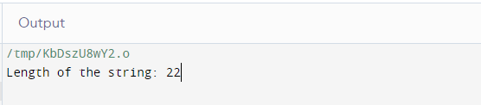

24. Write a program to print Factorial of a number using Recursion?

#include<stdio.h>

long factorial(int n) {

if (n == 0)

return 1;

else

return(n * factorial(n-1));

}

void main() {

int number;

long fact;

printf("Enter a number: ");

scanf("%d", &number);

fact = factorial(number);

printf("Factorial of %d is %ld\n", number, fact);

return 0;

}

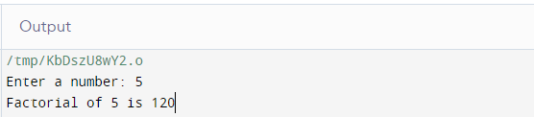

25. Write a c program to print multiplication of 2 matrics.

#include<stdio.h>

int main(){

int a[10][10],b[10][10],mul[10][10],r,c,i,j,k;

printf("enter the number of row=");

scanf("%d",&r);

printf("enter the number of column=");

scanf("%d",&c);

printf("enter the first matrix element=\n");

for(i=0;i<r;i++){

for(j=0;j<c;j++){

scanf("%d",&a[i][j]);

}

}

printf("enter the second matrix element=\n");

for(i=0;i<r;i++){

for(j=0;j<c;j++)

{

scanf("%d",&b[i][j]);

}

}

printf("multiply of the matrix=\n");

for(i=0;i<r;i++)

{

for(j=0;j<c;j++)

{

mul[i][j]=0;

for(k=0;k<c;k++)

{

mul[i][j]+=a[i][k]*b[k][j];

}

}

}

//for printing result

for(i=0;i<r;i++)

{

for(j=0;j<c;j++)

{

printf("%d\t",mul[i][j]);

}

printf("\n");

}

return 0;

}

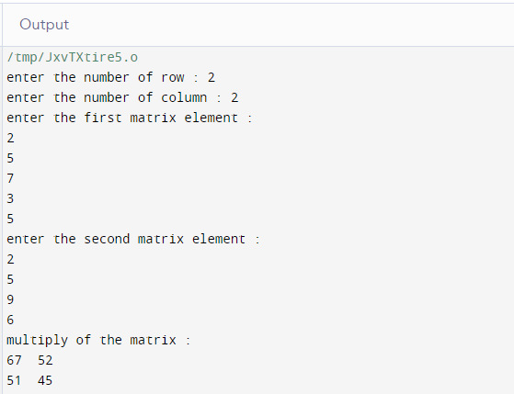

# **MY CODING STANDARDS**

# MY CODING STANDARDS

Listed below are the coding practices that I will follow:

Variable Naming

snake case letter will be used to denote the variable name,and first letter always will be start with capital letter and in my variable naming I use short form of data type to easily identify variable data type at any place I use “In” for int, “Ch” for char “Fl” for float and so on. Data type short name use in starting of variable with underscore to define a variable name.

Eg: int In_age; char Ch_letter; float Fl_value; double D_value;

Function Naming:

camel case will be used to define functions, I.e the 1st letter will be small and the 1st letter of the next words will be capital.

Eg: void addFun(); int addFun();

Indentations:

space of one tab will be left when there is the use of ‘{‘, plus any other time there is a need to separate the coming part from the general flow of control like calling a function. And use the inline comment in end of the control statement that can easy to understand where any control statement is ending.

Eg: for(int i=0; i<10; i++){

int In_a=0; // initialize a

a=i; //assign the value

} //end of for loop

4. Comments:

In my coding standard I use single line comment use to define the end of loop and end of the statement braces that help to understand that where is a statement ending and I will use multi-line comments to define a control statement , function and methods because it is very helpful to understand the work of any control statement, function and method.

**Eg:**

// create a function to calculate sum of a and b int myFunction(int a, int b) { int In_a1 = a; int In_b2 = b; return a1+b2;

}

int main() { int sum = myFunction(10,20); // call the function printf("%d",sum); return 0;

}

**5.** Sequencing:

the sequencing of the program will be as follows:

1. The copyright statement
2. #include commands
3. Function if need.
4. main function-
5. variable declaration and use the statements like control statement, conditional statement.

This sequence will ensure a uniform approach to the program that can be easily understood in later stages.

# *Assignment*

# Version Controlling

(Git Assignment)

**Step 1. Create a folder Programming lab.**

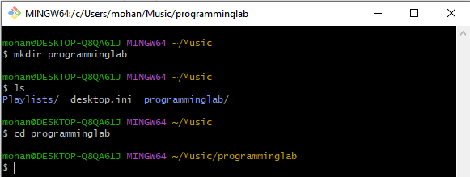

**Step 2. Cloning the existed Repository from My github**

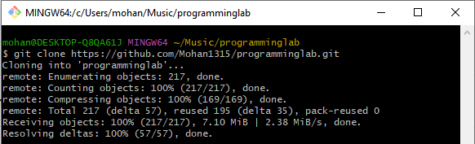

**Step 3. Creating a new Text file**

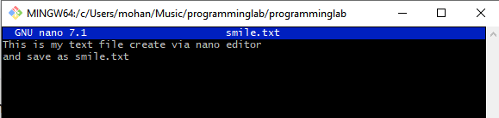

**Step 4. Adding it to Staging area and commit then push.**

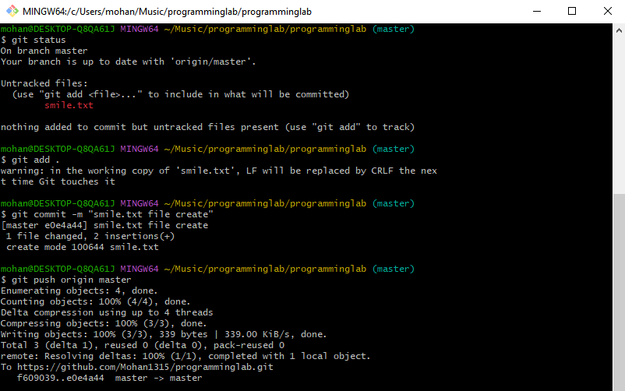

**Before Pushing**

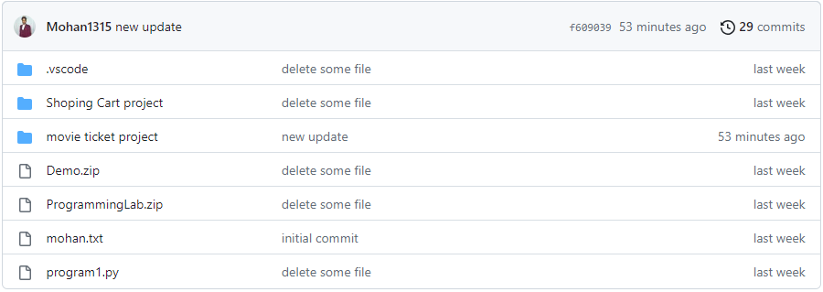

**After Pushing**

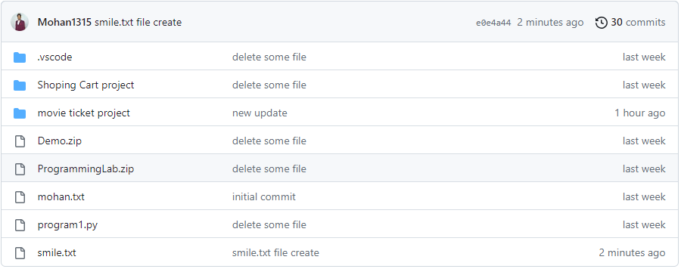

**Step 5. Switcing to New Branch.**

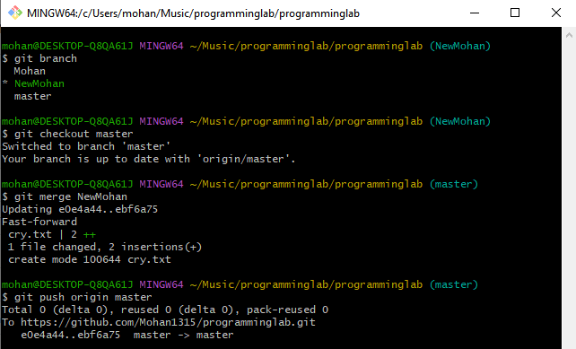

**Before adding New branch After pushing new Branch**

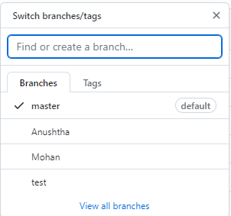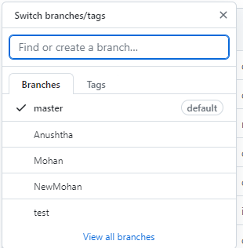

**Step 6. Creating File on new Branch.**

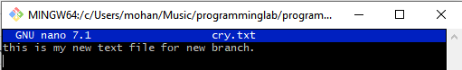

**Pushing File in Git through new Branch**

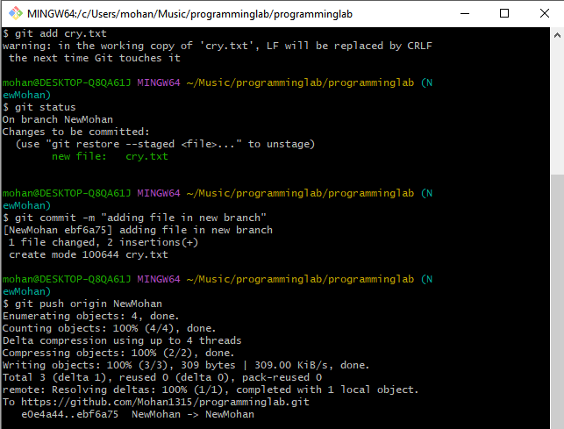



**Before Merging**

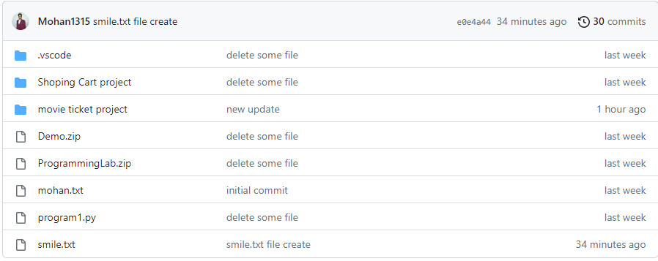

**After Merging**

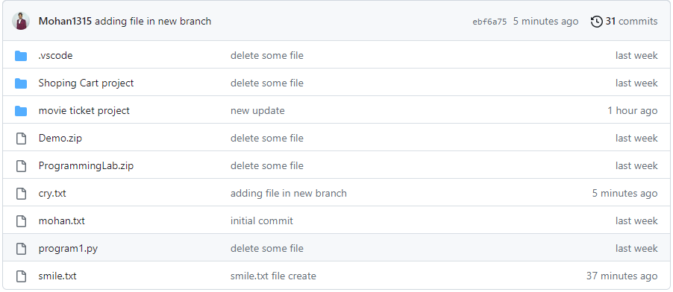

# Python Assignment

1. Using Pandas read any CSV file and display first five rows of that file.

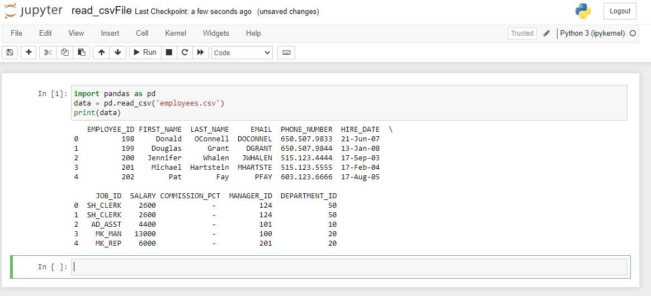

1. Write a python program to print the contents of a directory using OS module. Search online for the function which does that.

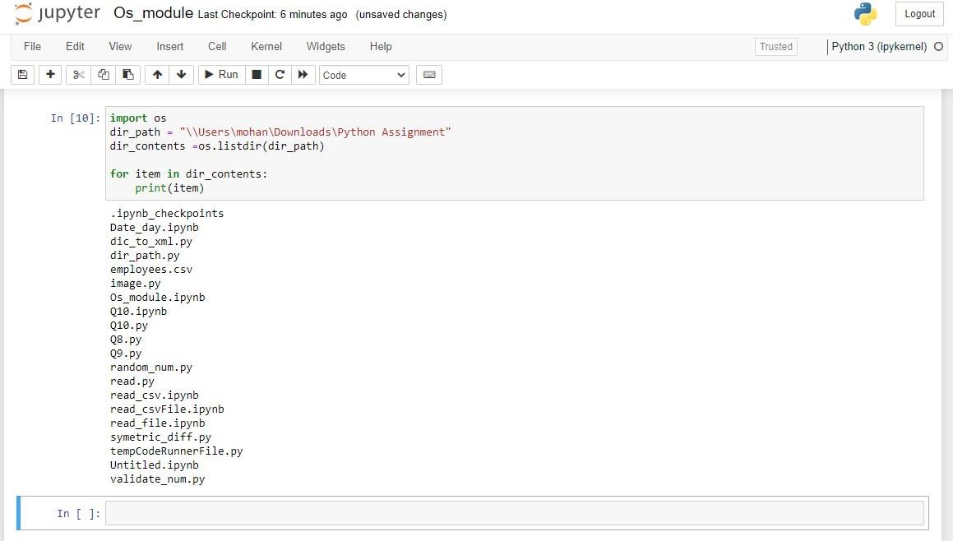

1. Write a program to read image and find size and shape of image using external module.

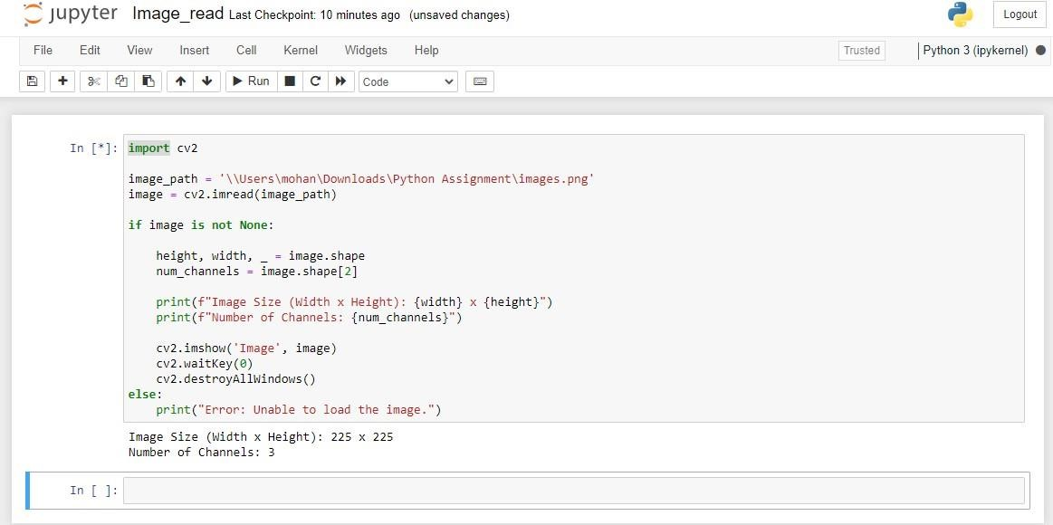

1. Please write a program to make a list of random numbers between 0 to 10 and output numbers from that list which is divisible by 5 or 7, using random module.

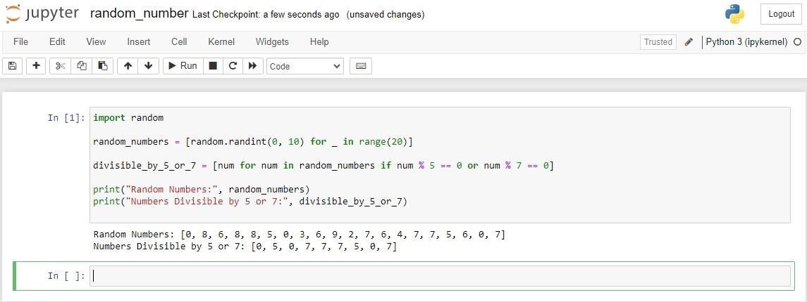

1. Write a python program to convert dictionary to xml.

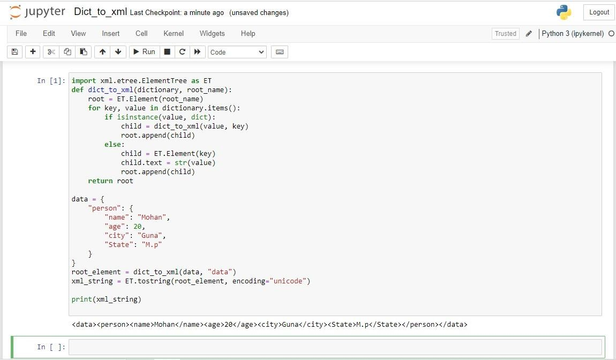

1. Write a program to validate phone number.

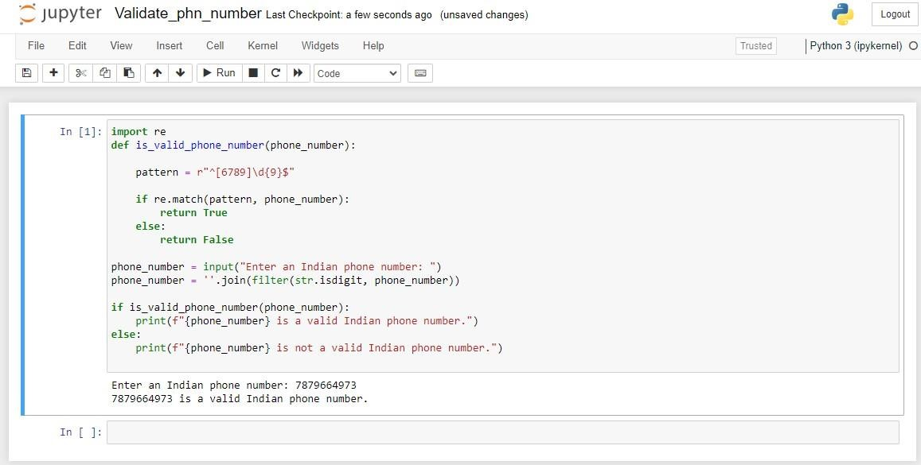

1. Given 2 sets of integers, M and N, print their symmetric difference in ascending order. The term symmetric difference indicates those values that exist in either M or N but do not exist in both.

Input Format :

The first line of input contains an integer, M.

The second line contains M space-separated integers.

The third line contains an integer, N.

The fourth line contains N space-separated integers.

Output Format :

Output the symmetric difference integers in ascending order, one per line.

Sample Input :

4

2 4 5 9

4

2 4 11 12

Sample Output:

5 9

11

12

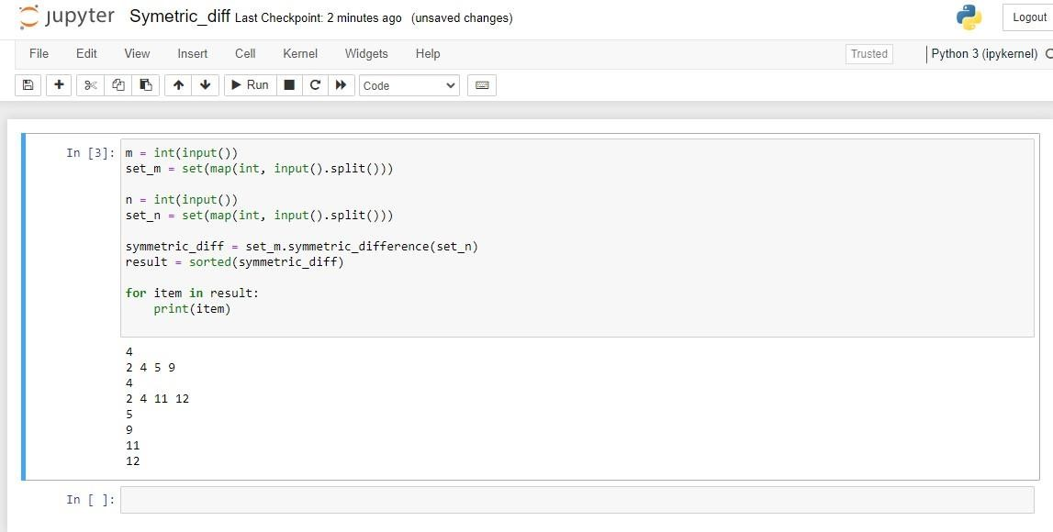

1. Consider a list (list = []). You can perform the following commands:
2. insert i e: Insert integer e at position i.
3. print: Print the list.
4. remove e: Delete the first occurrence of integer e.
5. append e: Insert integer e at the end of the list.
6. sort: Sort the list.
7. pop: Pop the last element from the list.
8. reverse: Reverse the list.

Initialize your list and read in the value of n followed by n lines of commands where each command will be of the 7 types listed above. Iterate through each command in order and perform the corresponding operation on your list. Sample Input

12 insert 0 5 insert 1 10 insert 0 6 print remove 6

append 9 append 1 sort print pop reverse print

Sample Output

[6, 5, 10]

[1, 5, 9, 10]

[9, 5, 1]

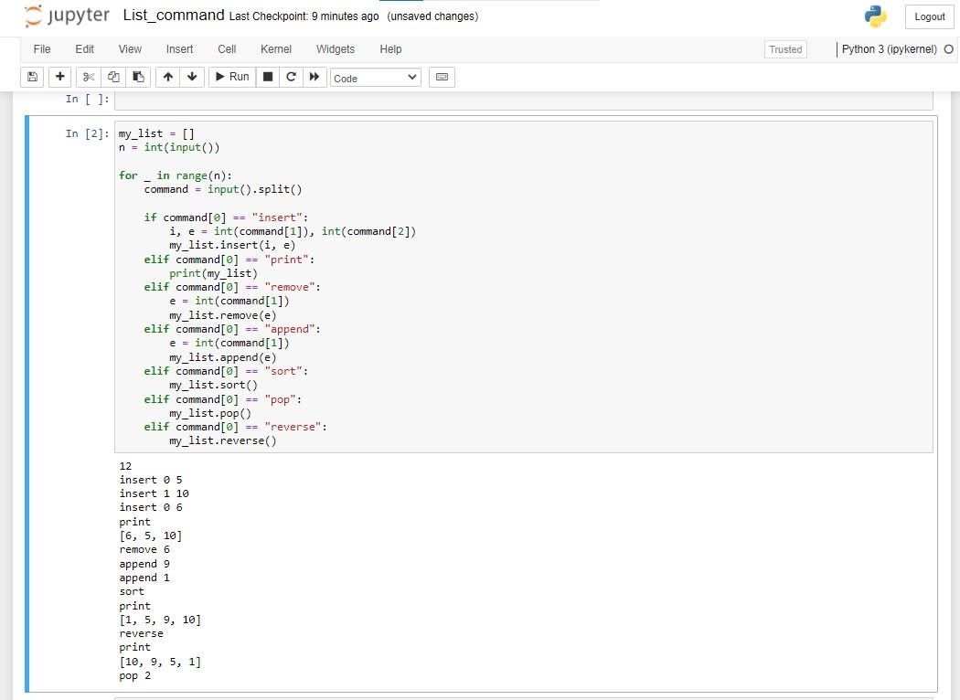

1. You are given a date. Your task is to find what the day is on that date

Input Format

A single line of input containing the space separated month, day and year, respectively, in MM DD YYYY format.

Constraints

2000<year<3000

Output Format

Output the correct day in capital letters.

Sample Input

08 05 2015

Sample Output

WEDNESDAY

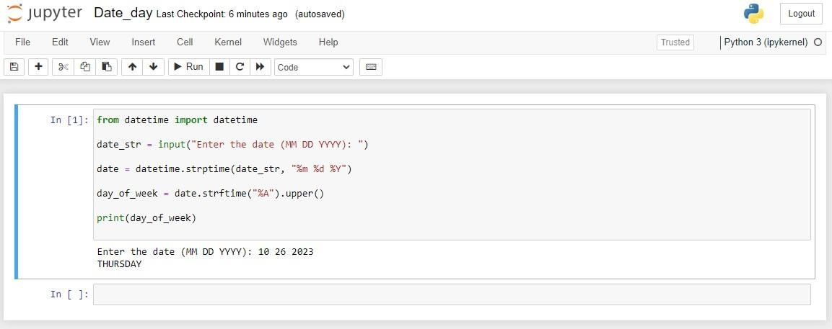

1. Write a program which accepts a sequence of words separated by whitespace as input to print the words composed of digits only.

Example: If the following words are given as input to the program: 2 cats and 3 dogs.

Then, the output of the program should be: ['2', '3']

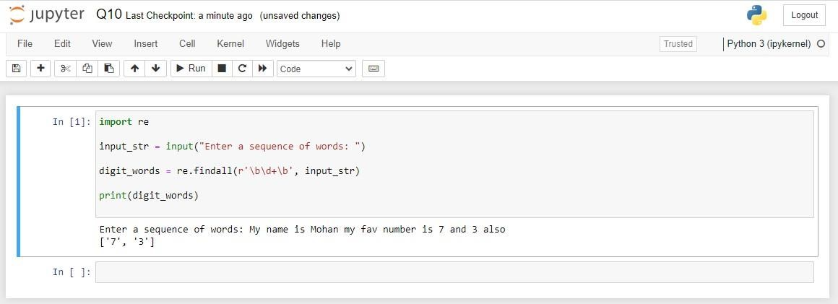

# Profilling Assignment

# Q.1 Use gprof to analyze and if required optimize the below program:

#include <stdio.h>

#include <stdlib.h>

// A function to generate random numbers and store them in an array

voidgenerate_random_numbers(int* array, int size) {

for (inti = 0; i< size; i++) {

array[i] = rand() % 1000;

}

}

// A function to find the sum of elements in an array

intfind_sum(int* array, int size) {

int sum = 0;

for (inti = 0; i< size; i++) {

sum += array[i];

}

return sum;

}

// A function to find the product of elements in an array

intfind_product(int* array, int size) {

int product = 1;

for (inti = 0; i< size; i++) {

product *= array[i];

}

return product;

}

int main() {

constint size = 10000; // Size of the array (adjust as needed)

int* array = (int*)malloc(size * sizeof(int));

generate_random_numbers(array, size);

int sum = find_sum(array, size);

int product = find_product(array, size);

printf("Sum: %d\n", sum);

printf("Product: %d\n", product);

free(array);

return 0;

}

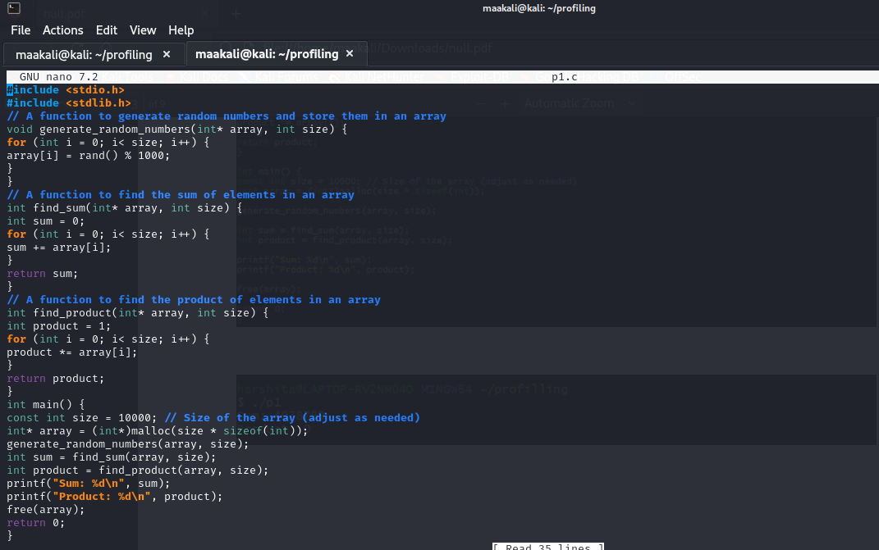

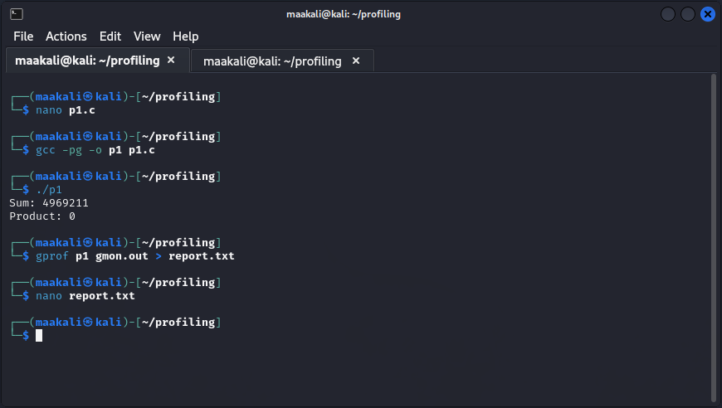

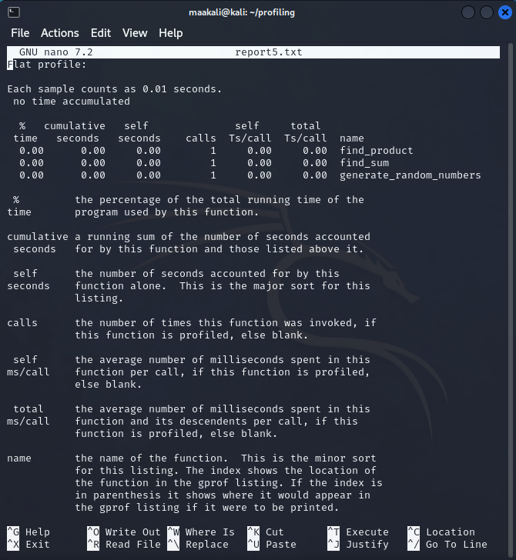

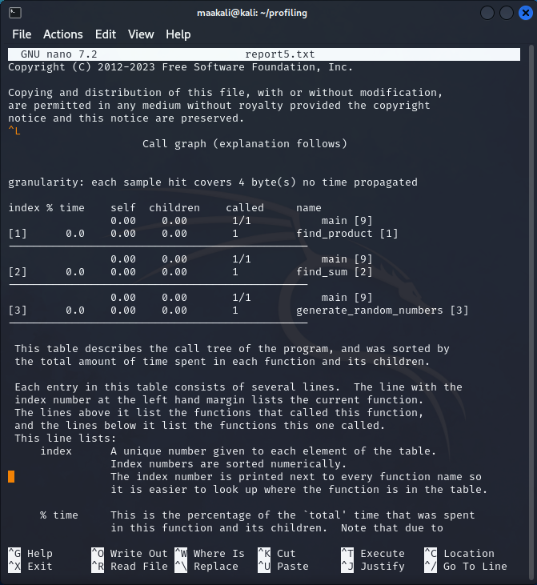 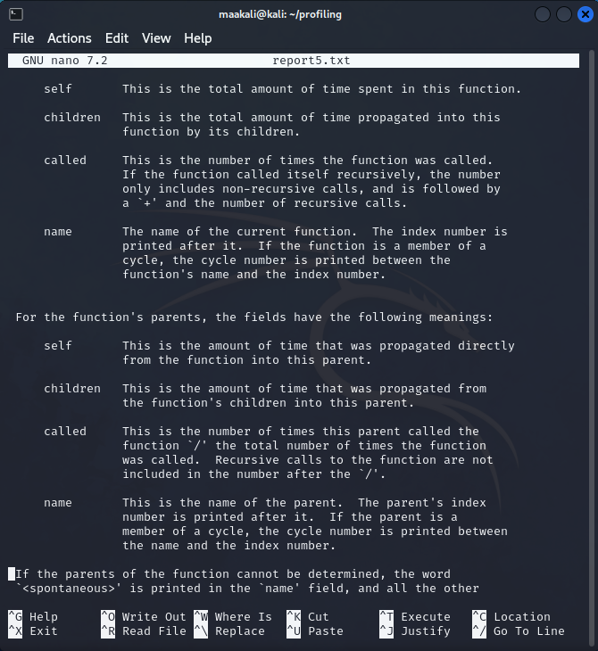

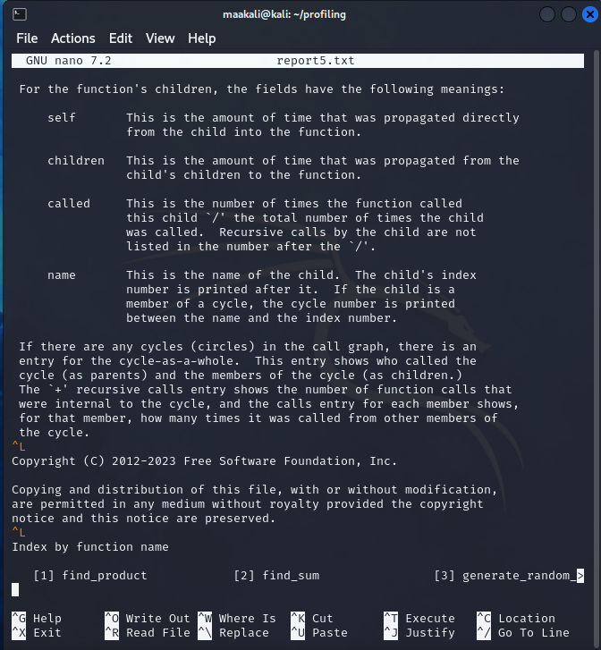

Que 2 Write a program to print the factorial of a number which is taken as input and use gprof to optimize.

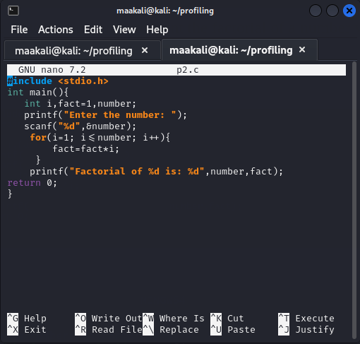

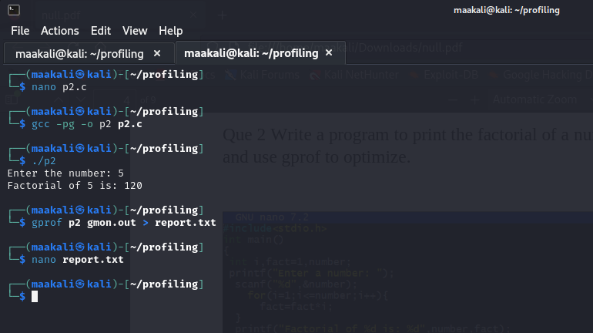 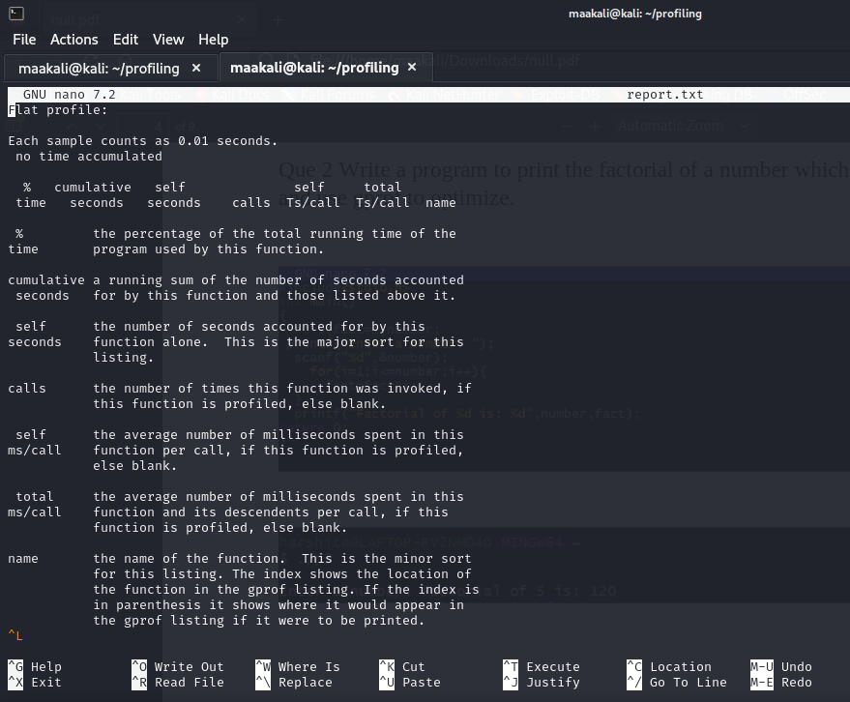

Q3. Write a program for calculator that can perform addition, subtraction, multiplication, division use gprof to optimize.

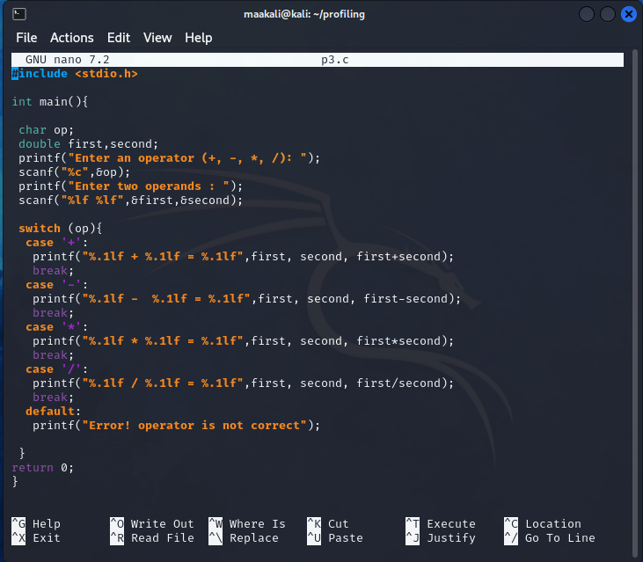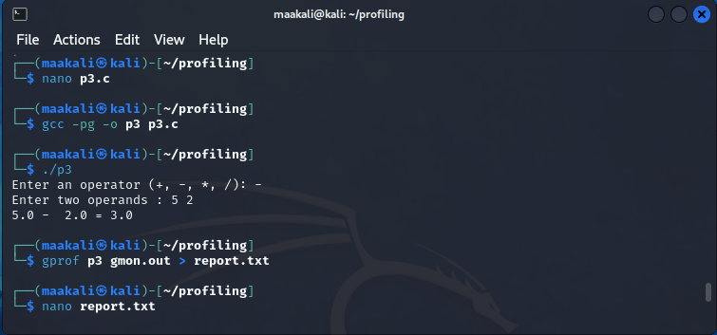

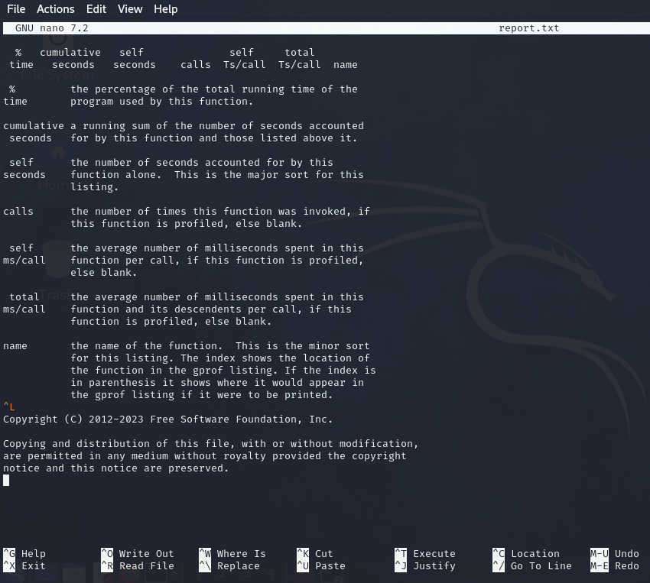

Que 4 Calculate the area and perimeter of common shapes (circle, rectangle, triangle, square) and use gprof to optimize.

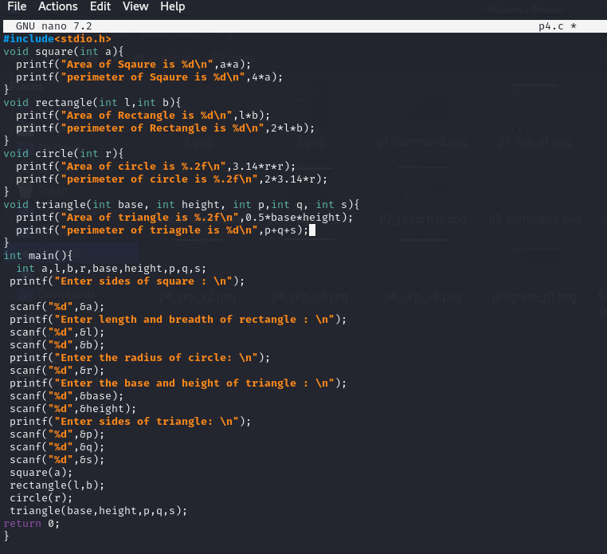

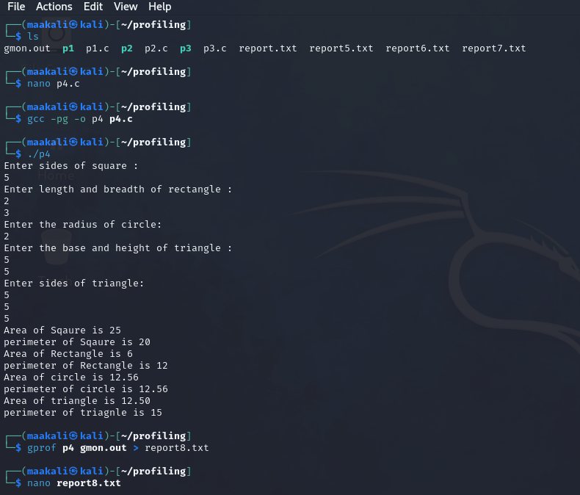

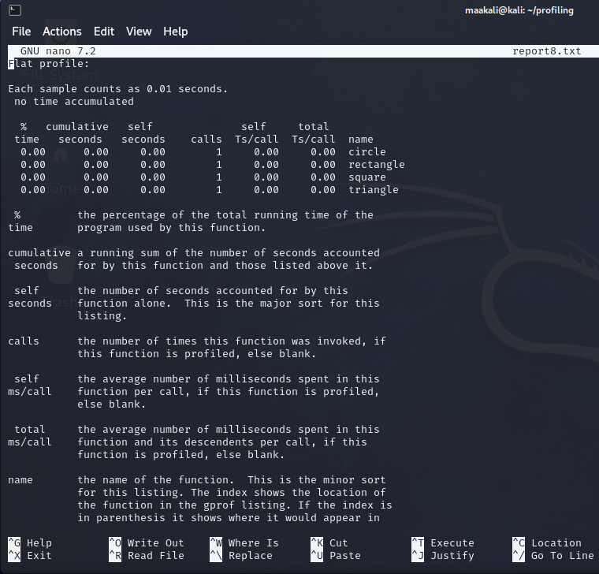

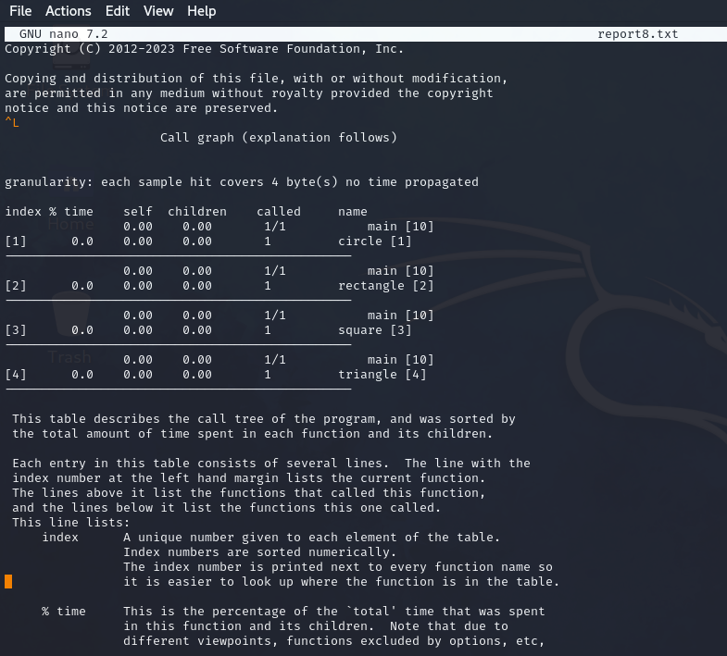

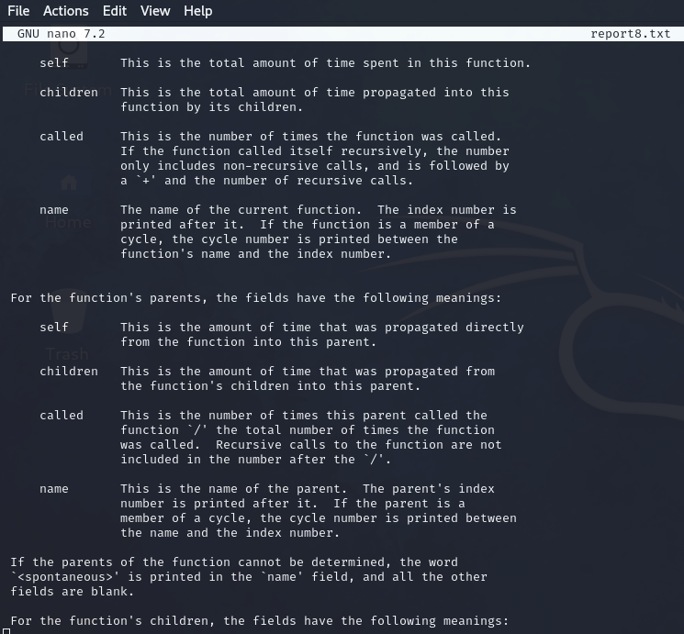

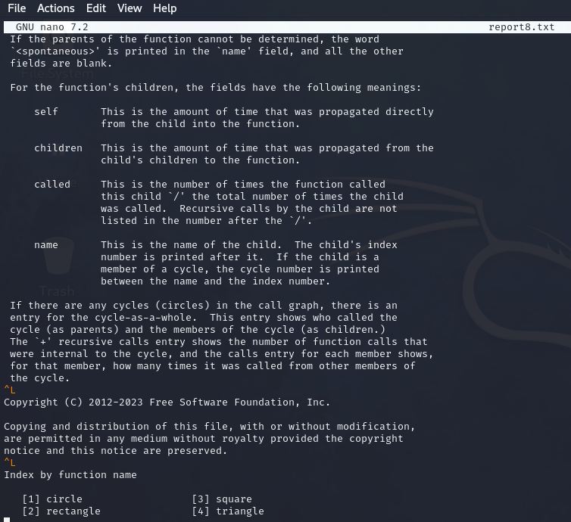

**Debugging Assignment**

Q1.

#include int main() {

int a,b;

int c=a+b;

printf("%d",c); // Output: 5

return 0;

}

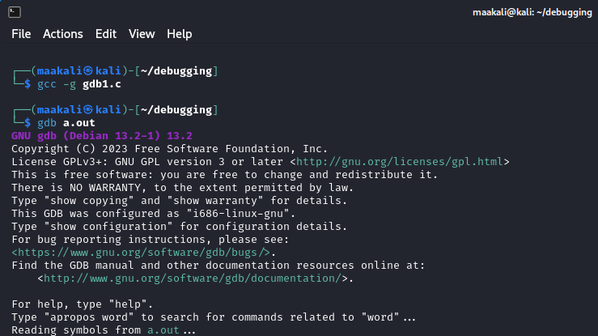

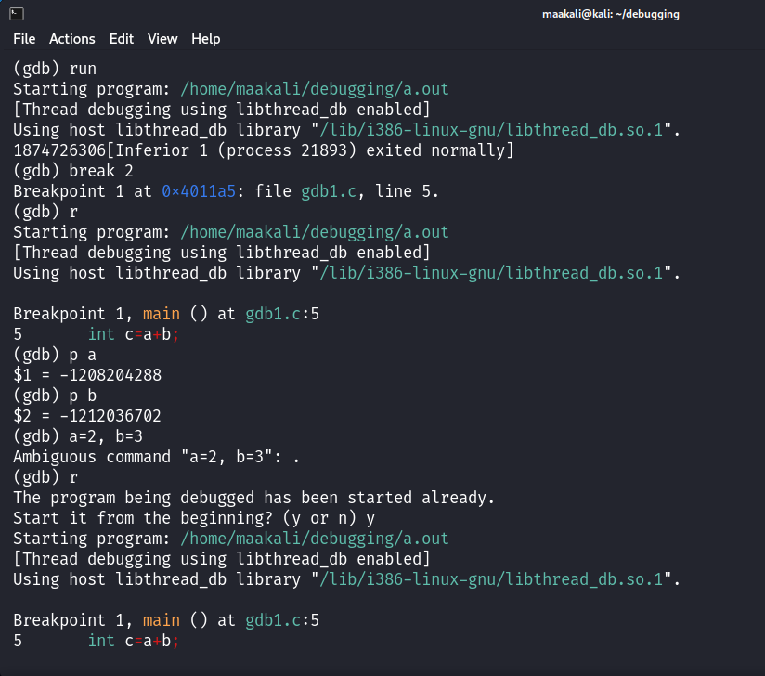

Q.2)

#include int main() {

int d=2;

printf("Enter the value of d:");

scanf("%d",d);

printf("The value of d is:%d",d);

return 0;

}

Correct code

#include <stdio.h>

int main()

{

int d=2;

printf("Enter the value of d:");

scanf("%d",&d);

printf("The value of d is:%d",d);

return 0;

}

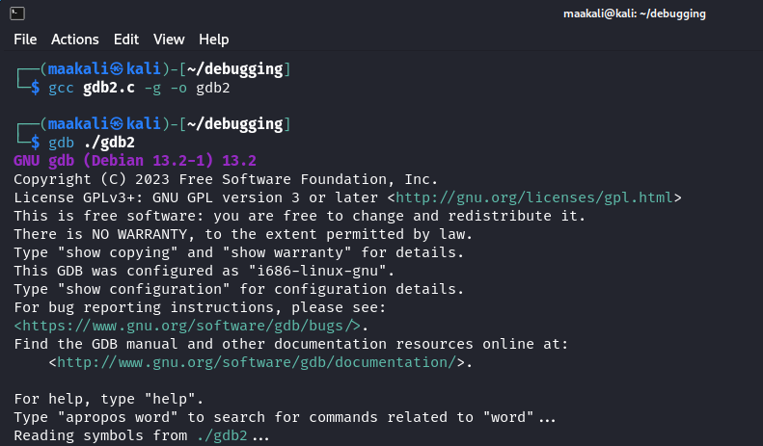

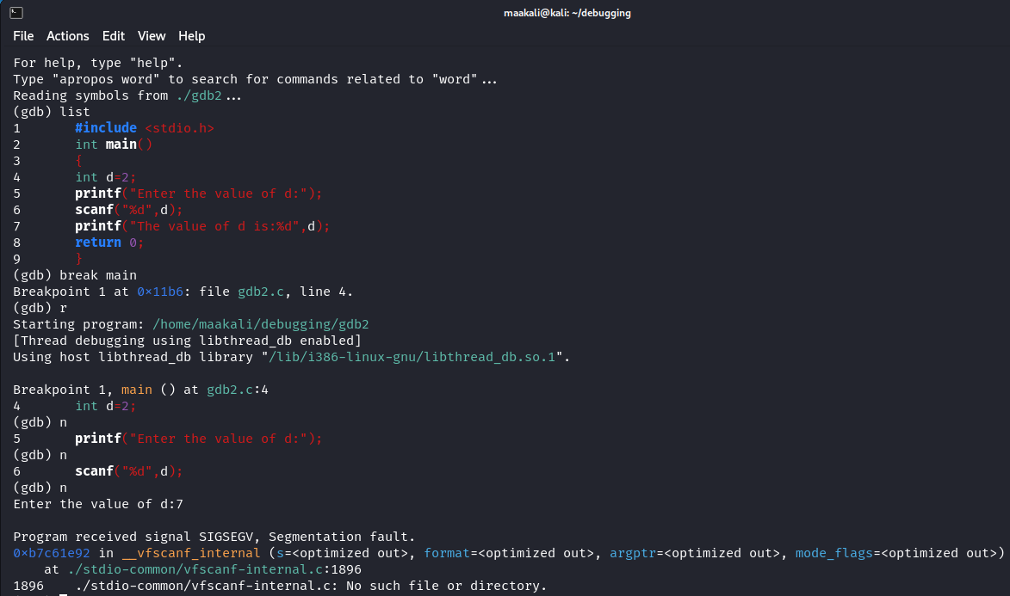

Q.3)

#include <stdio.h>

#include <stdlib.h>

int factorial(int n);

int main(void) {

int n = 5;

int f = factorial(n);

printf("The factorial of %d is %d.\n", n, f); n = 17;

f = factorial(n);

printf("The factorial of %d is %d.\n", n, f); return 0;

}

//A factorial is calculated by n! = n * (n - 1) * (n - 2) * ... * 1 //E.g. 5! = 5 * 4 * 3 * 2 * 1 = 120

int factorial(int n)

{ int f = 1; int i = 1;

while (i <= n) { f = f * i; i++; }

return f;

}

Correct code Q.3

#include <stdio.h>

#include <stdlib.h>

long long int factorial(int n);

int main(void) {

int n = 5;

long long int f = factorial(n);

printf("The factorial of %d is %lld.\n", n, f);

n = 17;

f = factorial(n);

printf("The factorial of %d is %lld.\n", n, f);

return 0;

}

//A factorial is calculated by n! = n * (n - 1) * (n - 2) * ... * 1

//E.g. 5! = 5 * 4 * 3 * 2 * 1 = 120

long long int factorial(int n) {

long long int f = 1;

int i = 1;

while (i <= n) {

f = f * i;

i++;

}

return f;

}

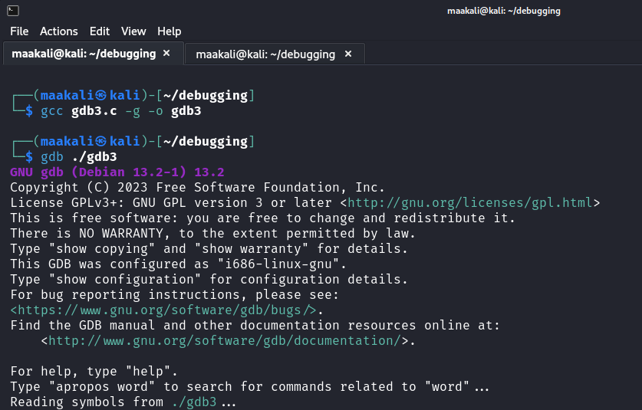

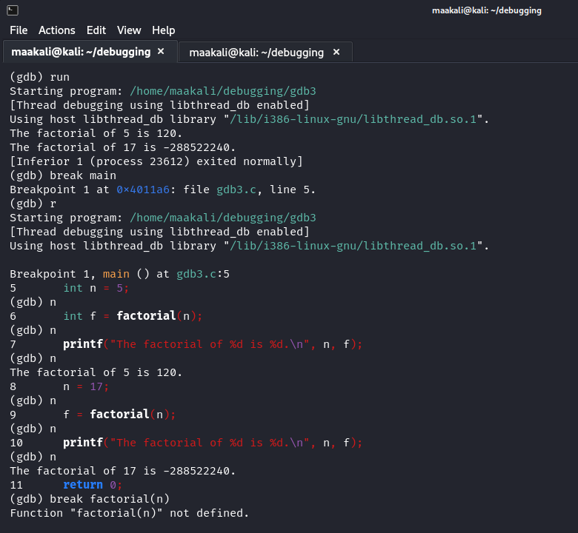

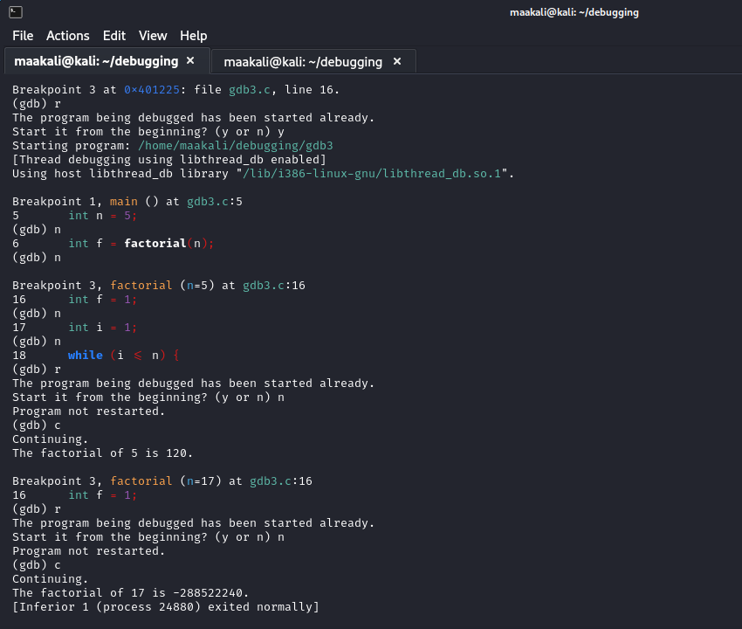

**Q.4)**

#include <stdio.h>

int main(void) {

int arr[2];

arr[3] = 10; // Accessing out of bound

return (0);

}

Correct code for Q.4):-

#include <stdio.h>

int main(void) {

int arr[4];

arr[3] = 10;

return (0);

}

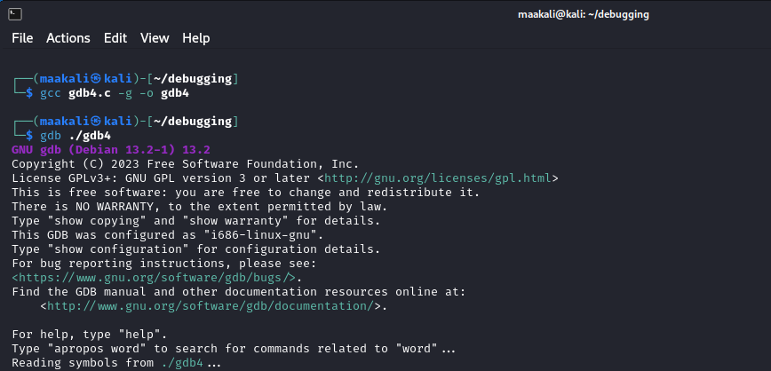

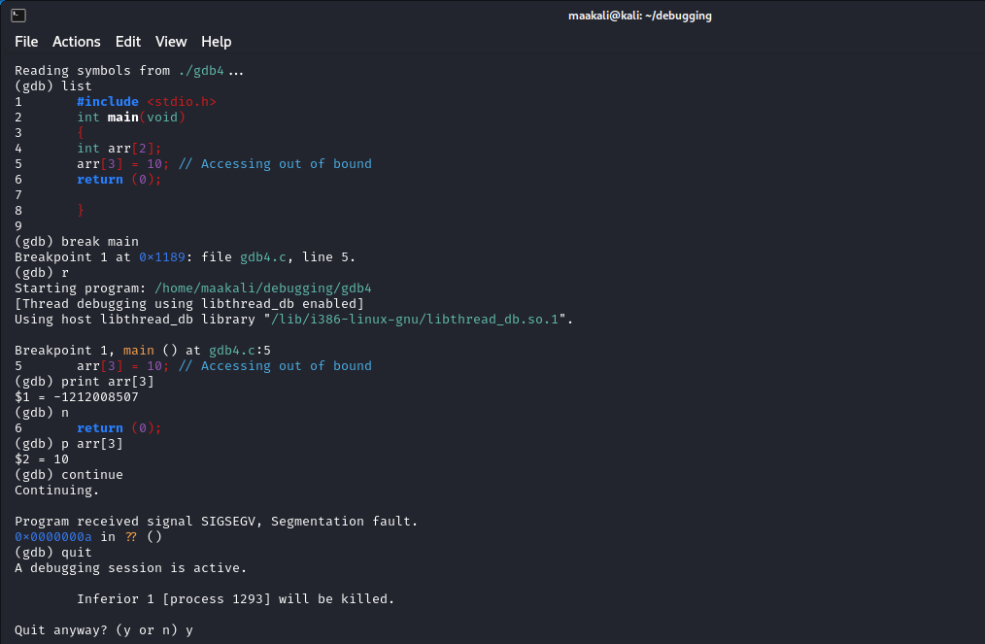

**Q.5)**

#include <stdio.h>

int main(){

int *p;

printf("%d",*p);

return 0;

}

Correct code Q.5):-

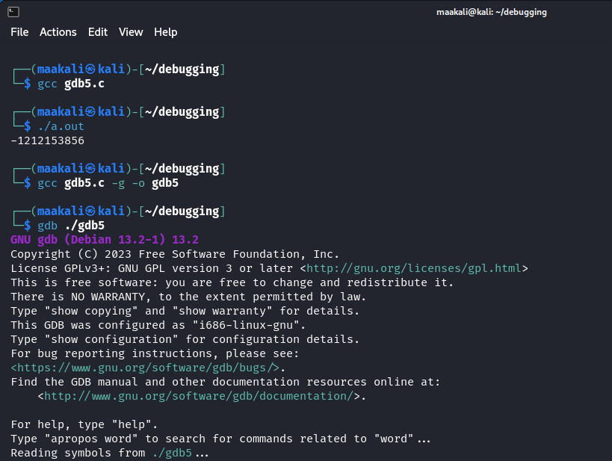

#include <stdio.h>

int main()

{

int *p;

int var = 15;

p = &var;

printf("%d",*p);

return 0;

}

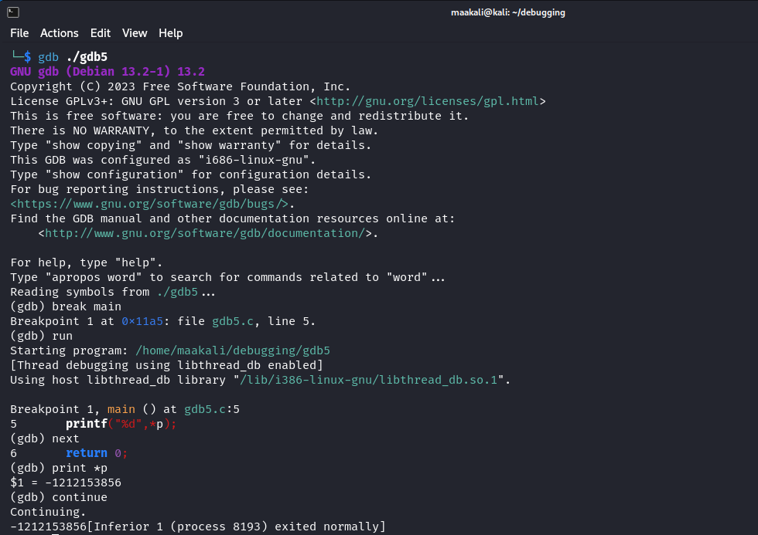

**Latex Assignment**

**Latex Source Code**

\documentclass[10pt]{article}

\usepackage{microtype}

\usepackage{graphicx} % Required for inserting images

\usepackage{blindtext}

\usepackage{geometry}

\usepackage{multirow}

\usepackage{enumerate}

\usepackage{tabto}

\usepackage{inputenc}

\usepackage{enumitem,amssymb}

\newlist{todolist}{itemize}{2}

\setlist[todolist]{label=$\square$}

\geometry{

a4paper,

total={170mm,257mm},

left=20mm,

top=10mm,

}

\begin{document}

\begin{flushright}JEE (Advanced) 2022 \;\;\;\;\;\;\;\;\;\;\;\;\;\;\;\;\;\;\;\;\;\;\;\;\;\;\;\;\;\;\;\;\;\;\;\;\;\;\;\;\;\;\;\;\;\;\;\;\;\;\;\;\;\;\;\;\;\;\;\;\;\;\;\;\;\;\;\;\;\;\;\;\;\;\;\;\;\;\;\;\;\;\;\;\;\;\;\;\;\;\;\;\;\;\;\;\;\;\;\;\;\;\;\;\;\;\;\;\;\;\;Mohan Manjhi\end{flushright}

$$\textbf{------------------------------------------------------------------------------------------------------------------------------}$$

\begin{center}

\fbox{\parbox{6.5in}{

\begin{center}

\includegraphics[width=0.25\linewidth]{iitB.png}

\end{center}

\hspace*{4ex}Name : Mohan Manjhi \tab \hspace*{10ex}Max Marks : 70\\ \\ \hspace*{4ex}Branch : C.S.E \tab \hspace*{10ex}Min Marks : 22\\ \\ \hspace*{4ex}Subject : Latex Assignment\tab \hspace*{10ex}Time : 03:00 HRS \\ \\

\hspace*{4ex}Signature of the Examiner with date \tab \hspace*{10ex}Signature of the Scrutinizer with date\\ \\

\hspace*{4ex}------------------------------------------------\tab \hspace*{12ex}------------------------------------------------\\ \\

}}

\end{center}

READ THE INSTRUCTIONS CAREFULLY \\

GENERAL \\

\begin{itemize}

\item This sealed booklet is your Question Paper. Do not break the seal till you are told to do so.

\end{itemize}

\begin{itemize}

\item Immediately after breaking the seal of the booklet, verify that the booklet contains 23 pages and that all the 16 questions along with the options are legible.

\end{itemize}

\begin{itemize}

\item Report immediately about any missing or torn sheet in this booklet and ask for a replacement of the booklet from the invigilator. No replacement will be allowed after 15 minutes of the starting of the examination.

\end{itemize}

\begin{itemize}

\item Write your Name, Roll Number, JEE (Advanced) 2022 Rank and other details in the space provided and nowhere else. No distinctive / identification mark of any type is to be put anywhere else in this booklet.

\end{itemize}

\begin{itemize}

\item Answers are to be written only in the booklet and within the space provided beside / below each Question and nowhere else. Answers written in nondesignated place will not be evaluated.

\end{itemize}

\begin{itemize}

\item Blank spaces are provided within this booklet for rough work.

\end{itemize}

\begin{itemize}

\item Do not deface this booklet or detach or mutilate any sheet from the booklet. Such acts lead to disqualification.

\end{itemize}

\begin{itemize}

\item All the questions are compulsory.

\end{itemize}

\newpage

\begin{flushright}JEE (Advanced) 2022 \;\;\;\;\;\;\;\;\;\;\;\;\;\;\;\;\;\;\;\;\;\;\;\;\;\;\;\;\;\;\;\;\;\;\;\;\;\;\;\;\;\;\;\;\;\;\;\;\;\;\;\;\;\;\;\;\;\;\;\;\;\;\;\;\;\;\;\;\;\;\;\;\;\;\;\;\;\;\;\;\;\;\;\;\;\;\;\;\;\;\;\;\;\;\;\;\;\;\;\;\;\;\;\;\;\;\;\;\;\;\;Mohan Manjhi\end{flushright}

$$\textbf{------------------------------------------------------------------------------------------------------------------------------}$$

\begin{center}

\fbox{\parbox{6.5in}{\centering

\textbf{SECTION A: Architectural Awareness (Maximum Marks: 60)}\\

This section contains \textbf{FOUR} questions. Question 1 carries \textbf{30 marks}, Questions 2, 3 \\

and 4 carry \textbf{10 marks} each. There is \textbf{NO} negative marking}}

\end{center}

%\begin{center}\textbf{SECTION A: Architectural Awareness (Maximum Marks: 60)}

% \\ %This section contains FOUR questions. Question 1 carries %30 marks, Questions 2, 3 \\ %and 4 carry 10 marks each. There is NO negative marking.

%\end{center}

Q.1. This section contains \textbf{15 multiple choice questions}. Each question has four options, out of which

ONLY \\

\hspace*{5ex}ONE is correct. Mark the correct option with a tick

\\ \begin{flushright}

\textbf{(5 x 2 = 10 Marks)}

\end{flushright}

(i) Which of the following bridges is laid over a sea? \\ \\

\hspace*{4ex}A. Godavari Bridge, Andhra Pradesh \\ \\

\hspace*{4ex}B. Pamban Bridge, Tamilnadu \\ \\

\hspace*{4ex}C. Howrah Bridge, West Bengal \\ \\

\hspace*{4ex}D. Mahatma Gandhi Setu, Bihar \\

%

\\ \\

(ii) In 2021, --------------------annual festivity got inscribed on the representative list of

Intangible Cultural \\

\hspace*{4ex}Heritage of Humanity by UNESCO.

\\ % \\

\hspace*{4ex}A. Makara Sankranthi \tab B. Ganesh Chaturthi \\ \\ \\

\hspace*{4ex}C. Durga Puja \tab D.Chhath Puja

\\ \\ % \\

(iii) Statue of which famous personality is called ‘Statue of Unity’?

\\ \\ % \\

\hspace*{4ex}A. Mahatma Gandhi \tab B. Dr. B. R. Ambedkar

\\ \\ \\

\hspace*{4ex}C. Sardar Vallabhbhai Patel \tab D.Indira Gandhi

\\ \\ % \\

(iv) Which of the following historic gateways is sharing an edge with a water body? \\

\\ % \\

\hspace*{4ex}A. Charminar, Hyderabad \tab B. India Gate, New Delhi \\ \\ \\

\hspace*{4ex}C. Rumi Darwaza, Lucknow \tab D.Gateway of India, Mumbai

\\ \\

%

\\ \\

(v) Which architect has designed the building ‘Church of Light’, located in Japan?

\\ \\ % \\

\hspace*{4ex}A. Moshe Safdie \tab B. Fumihiko Maki

\\ \\ \\

\hspace*{4ex}C. Zaha Hadid \tab D.Tadao Ando

\\ \\

$$\textbf{------------------------------------------------------------------------------------------------------------------------------}$$

%

\begin{flushright}JEE (Advanced) 2022 \;\;\;\;\;\;\;\;\;\;\;\;\;\;\;\;\;\;\;\;\;\;\;\;\;\;\;\;\;\;\;\;\;\;\;\;\;\;\;\;\;\;\;\;\;\;\;\;\;\;\;\;\;\;\;\;\;\;\;\;\;\;\;\;\;\;\;\;\;\;\;\;\;\;\;\;\;\;\;\;\;\;\;\;\;\;\;\;\;\;\;\;\;\;\;\;\;\;\;\;\;\;\;\;\;\;\;\;\;\;\;Mohan Manjhi\end{flushright}

$$\textbf{------------------------------------------------------------------------------------------------------------------------------}$$

Q.2 Match the famous architects in column I with their renowned projects in column II. \hspace{10ex}\textbf{( Mark : 05)}\\

%

\\ \\

\hspace*{4ex}\textbf{Column I} \tab \textbf{Column II }

\\ \\

\hspace*{4ex}(A) Charles Correa \tab (P) IIM Bangalore

\\ \\

\hspace*{4ex}(B) B V Doshi \tab (Q) Capitol Complex, Chandigarh

\\ \\

\hspace*{4ex}(C) Bimal Pate \tab (R) Central Vista, New Delhi

\\ \\

\hspace*{4ex}(D) Raj Rewal \tab (S) Dakshina Chitra, Chennai

\\ \\

\hspace*{4ex}(E) Le Corbusier \tab (T) Bharat Bhawan, Bhopal

\\ \\

\hspace*{4ex} \tab (U) Parliament Library, New Delhi

\\ \\

%

Q.3 Match the material in Column I with the craft in Column II. \hspace{28ex}\textbf{( Mark : 05)}\\

%

\\ \\

\hspace*{4ex}\textbf{Column I} \tab \textbf{Column II }

\\ \\

\hspace*{4ex}(A) Stone \tab (P) Origami

\\ \\

\hspace*{4ex}(B) Paper \tab (Q) Embroidery

\\ \\

\hspace*{4ex}(C) Glass \tab (R) Carving

\\ \\

\hspace*{4ex}(D) Fabric \tab (S) Carpentry

\\ \\

\hspace*{4ex}(E) Metal \tab (T) Etching

\\ \\

\hspace*{4ex} \tab (U) Filigree \\ \\ \\ \\ \\ \\ \\ \\ \\ \\ \\ \\ \\ \\ \\ \\ \\ \\ \\ \\ \\ \\

$$\textbf{------------------------------------------------------------------------------------------------------------------------------}$$

\newpage

\begin{flushright}JEE (Advanced) 2022 \;\;\;\;\;\;\;\;\;\;\;\;\;\;\;\;\;\;\;\;\;\;\;\;\;\;\;\;\;\;\;\;\;\;\;\;\;\;\;\;\;\;\;\;\;\;\;\;\;\;\;\;\;\;\;\;\;\;\;\;\;\;\;\;\;\;\;\;\;\;\;\;\;\;\;\;\;\;\;\;\;\;\;\;\;\;\;\;\;\;\;\;\;\;\;\;\;\;\;\;\;\;\;\;\;\;\;\;\;\;\;Mohan Manjhi\end{flushright}

$$\textbf{------------------------------------------------------------------------------------------------------------------------------}$$

Q.4 Refer to the following sketch of St. James’ Church, Delhi. Match the numbers mentioned in Column I

(highlighted in the sketch) with corresponding building elements in Column II.\hspace{10ex}\textbf{( Mark : 05)}

\includegraphics[width=1\linewidth]{q3.jpg}

\\ \\ \\

%

\\

\hspace*{4ex}\textbf{Column I} \tab \textbf{Column II}

\\ \\

\hspace*{4ex}(A) i \tab (P) Column

\\ \\

\hspace*{4ex}(B) ii \tab (Q) Pediment

\\ \\

\hspace*{4ex}(C) iii \tab (R) Plinth

\\ \\

\hspace*{4ex}(D) iv \tab (S) Dome

\\ \\

\hspace*{4ex}(E) v \tab (T) Architrave

\\ \\

\hspace*{4ex} \tab (U) Arch

\\ \\ \\ \\ \\ \\ \\ \\ \\ \\ \\ \\ \\ \\ \\ \\

$$\textbf{------------------------------------------------------------------------------------------------------------------------------}$$

\nextpage

\begin{flushright}JEE (Advanced) 2022 \;\;\;\;\;\;\;\;\;\;\;\;\;\;\;\;\;\;\;\;\;\;\;\;\;\;\;\;\;\;\;\;\;\;\;\;\;\;\;\;\;\;\;\;\;\;\;\;\;\;\;\;\;\;\;\;\;\;\;\;\;\;\;\;\;\;\;\;\;\;\;\;\;\;\;\;\;\;\;\;\;\;\;\;\;\;\;\;\;\;\;\;\;\;\;\;\;\;\;\;\;\;\;\;\;\;\;\;\;\;\;Mohan Manjhi\end{flushright}

$$\textbf{------------------------------------------------------------------------------------------------------------------------------}$$

Q.5 Read the following statements and choose the correct options. \hspace{30ex}\textbf{( Mark : 07)}\\ \\

\hspace*{10ex}Statement A : Parapet is a type of window \\

\hspace*{10ex}Statement B : Pile is a type of foundation

\\ \\

%

\hspace*{4ex}A. Both the statements A \& B are True \\ \\

\hspace*{4ex}B. Both the statements A \& B are False \\ \\

\hspace*{4ex}C. The statement A is True but statement B is False \\ \\

\hspace*{4ex}D. The statement B is False but statement A is True \\

%

\\

Q.6 Refer to the graphical representation of timber, shown in figure 1

graphical representation shown in

figure 2, indicate? \tab \hspace{40ex}\textbf{( Mark : 07)}\\ \\

%

\\

\hspace*{10ex}\includegraphics[width=0.40\linewidth]{q6_fig1.jpg}

\hspace*{4ex}\includegraphics[width=0.36\linewidth]{q6_fig2.jpg} \\ \\

\hspace*{25ex} Figure 1 \tab \hspace*{15ex} Figure 2

\\ \\

%

\\ \hspace*{4ex}A. Thermocol \tab B. Concrete

\\ \\ \\

\hspace*{4ex}C. Steel \tab D.Brick

\\ \\

Q.7 The least value of $ \alpha\epsilon R \hspace*{1ex} for \hspace*{1ex} which \hspace*{1ex} 4\alpha x^2 + 1/x\ge 1, for \hspace*{1ex} all \hspace*{1ex} x>0, is $ \hspace{20ex}\textbf{( Mark : 07)} \\

\\

$\hspace*{4ex}A.\hspace*{4ex} \frac{1}{64} $\\ \\

$\hspace*{4ex}B.\hspace*{4ex} \frac{1}{32} $\\ \\

$\hspace*{4ex}C.\hspace*{4ex} \frac{1}{27} $\\ \\

$\hspace*{4ex}D.\hspace*{4ex} \frac{1}{25} $\\

\\ \\ \newpage

\begin{flushright}JEE (Advanced) 2022 \;\;\;\;\;\;\;\;\;\;\;\;\;\;\;\;\;\;\;\;\;\;\;\;\;\;\;\;\;\;\;\;\;\;\;\;\;\;\;\;\;\;\;\;\;\;\;\;\;\;\;\;\;\;\;\;\;\;\;\;\;\;\;\;\;\;\;\;\;\;\;\;\;\;\;\;\;\;\;\;\;\;\;\;\;\;\;\;\;\;\;\;\;\;\;\;\;\;\;\;\;\;\;\;\;\;\;\;\;\;\;Mohan Manjhi\end{flushright}

$$\textbf{------------------------------------------------------------------------------------------------------------------------------}$$

Q.8 A system goes from A to B via two processes I and II as shown in figure. If $\Delta$U1 and $\Delta$U2 are the changes

in internal energies in the processes I and II respectively, then \hspace{30ex}\textbf{( Mark : 07)} \\

$$ \centering

\includegraphics[width=0.25\linewidth]{Q8.jpg} $$

$\hspace*{4ex}A.\hspace*{4ex} \Delta U_{II} >\Delta U_I $\\ \\

$\hspace*{4ex}B.\hspace*{4ex} \Delta U_{II}<\Delta U_I $\\ \\

$\hspace*{4ex}C.\hspace*{4ex} \Delta U_I= \Delta U_{II} $\\ \\

\hspace*{4ex}D.\hspace*{4ex} Relation between $\Delta$ $U_I$ and $\Delta$ $U_{II}$ can not be determined \\

%

\\

Q.9 Consumers were polled about their favourite ice cream flavours in a survey. Draw a bar graph for

the following data: \tab \hspace{42ex}\textbf{( Mark : 07)}\\

\\ \begin{tabular}{|c|c|}

\hline

Flavour of Icecream & Frequency \\

\hline

Vanilla & 1\\

\hline

Strawberry & 5 \\

\hline

Chocolate & 12 \\

\hline

Mint Chocolate & 3 \\

\hline

Others & 6 \\

\hline

\end{tabular} \\

\\ \\

Q.10 Examine the graph below carefully and answer the following questions. The graph depicts the results of a school’s students. \tab \hspace{42ex}\textbf{( Mark : 10)}

\includegraphics[width=0.85\linewidth]{q10.jpg} \\

%

\\

\hspace*{4ex}A. Which year has the smallest difference between the number of kids who passed and those who failed? \\ \\

\hspace*{4ex}B. In the last five years, what was the average number of kids who failed in school? \\ \\

\hspace*{4ex}C. How many times have the same number of kids failed? \\ \\

\end{document}

**\* ASSIGNMENT \***

**PROGRAMMING INFRASTRUCTURE**

1. Push below code in git hub and then clone it from github and after correcting the code again

push it into any other branch.(in vscode)

def prit(n, isPrime):

isPrime[0] = isPrime[1] = False

for i in range(2,n):

isPrime[i] = True

for p in range(2,n+1):

if (p*p<=n and isPrime[p] == True):

for i in range(p*2,n+1,p):

isPrime[i] = False

p += 1

def superPrimes(n):

isPrime = [1 for i in range(n+1)]

prit(n, isPrime)

primes = [0 for i in range(2,n+1)]

j = 0

for p in range(2,n+1):

if(isPrime[p]):

primes[j] = p

j += 1

for k in range(j):

if(isPrime[k+1]):

print (primes[k],end=" ")

n = 241

print ("\nSuper-Primes less than or equal to ", n, " are :",)

superPrimes(n)

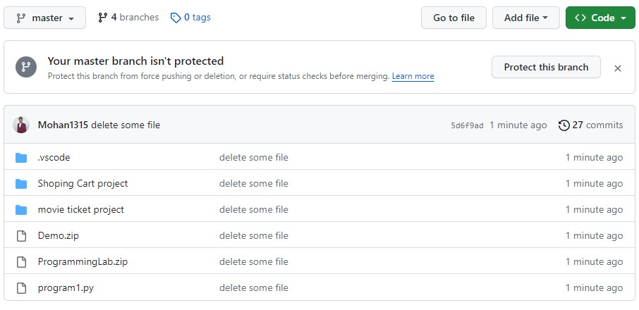

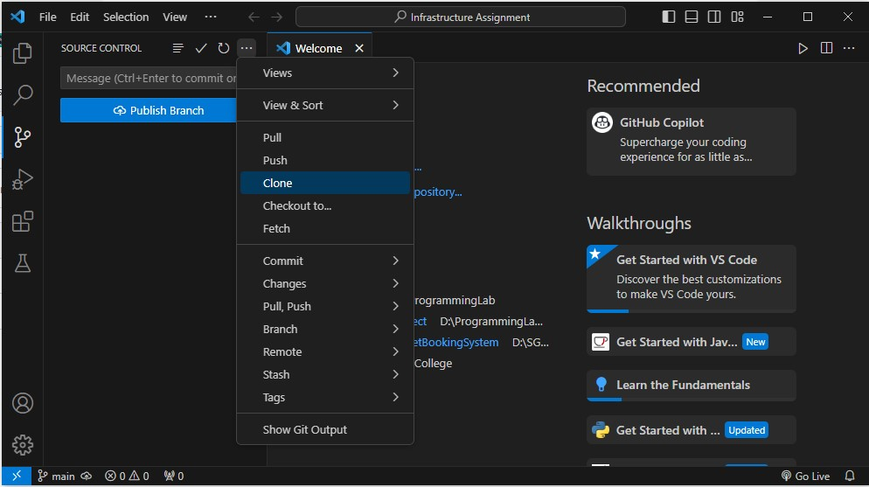

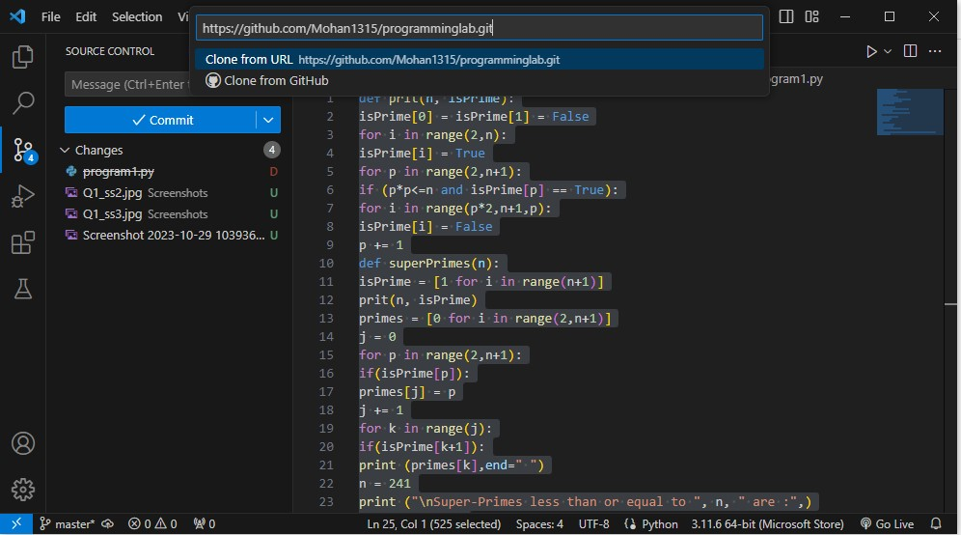

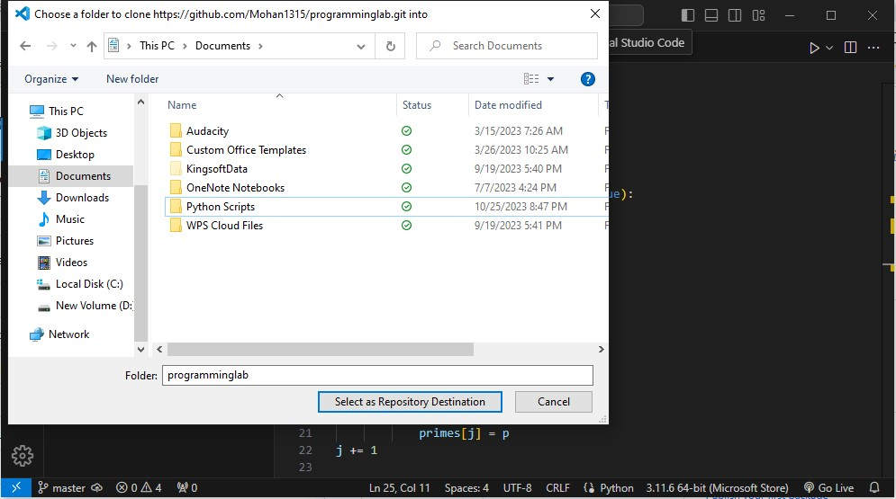

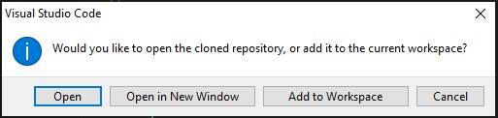

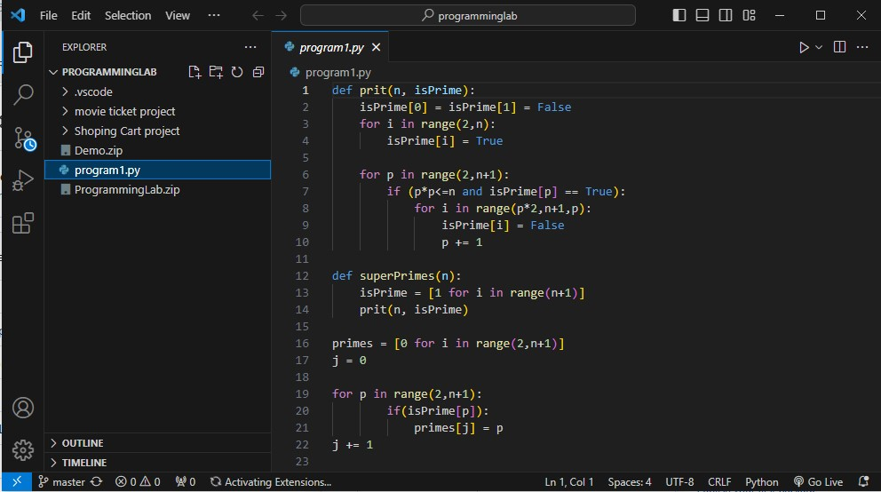

2. Compile the given code and check whether output of the following program is correct or not, if

not debug it using vscode and correct the code accordingly.

def prit(n, isPrime):

isPrime[0] = isPrime[1] = False

for i in range(2,n):

isPrime[i] = True

for p in range(2,n+1):

if (p*p<=n and isPrime[p] == True):

for i in range(p*2,n+1,p):

isPrime[i] = False

p += 1

def superPrimes(n):

isPrime = [1 for i in range(n+1)]

prit(n, isPrime)

primes = [0 for i in range(2,n+1)]

j = 0

for p in range(2,n+1):

if(isPrime[p]):

primes[j] = p

j += 1

for k in range(j):

if(isPrime[k+1]):

print (primes[k],end=" ")

n = 241

print ("\nSuper-Primes less than or equal to ", n, " are :",)

superPrimes(n)

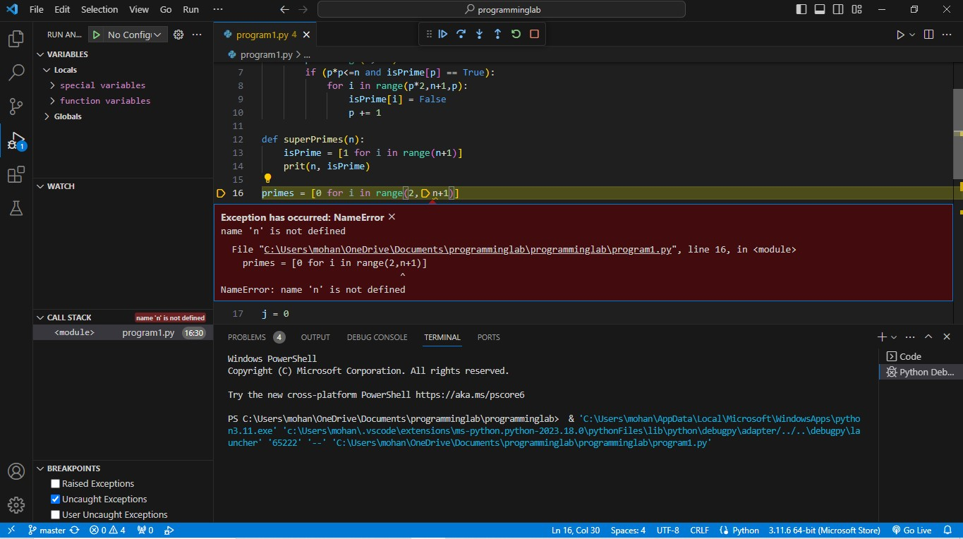

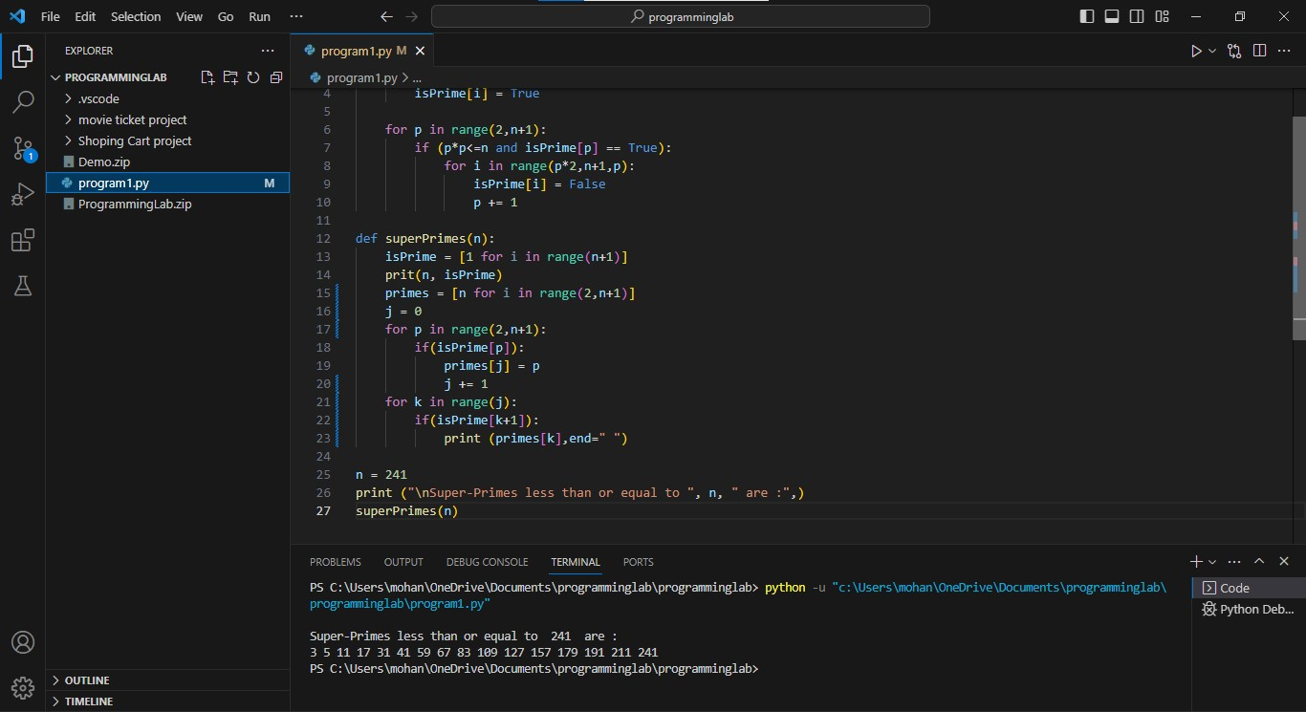

3. Refactoring below code by using pylance in vscode.

yy = 2017

print(calendar.calendar(yy))

cwd = os.getcwd()

print("Current working directory:", cwd)

result = os.path.exists("file_name")

print(result)

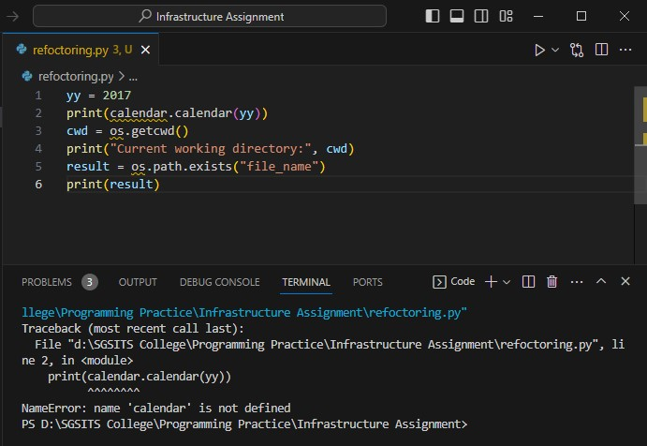

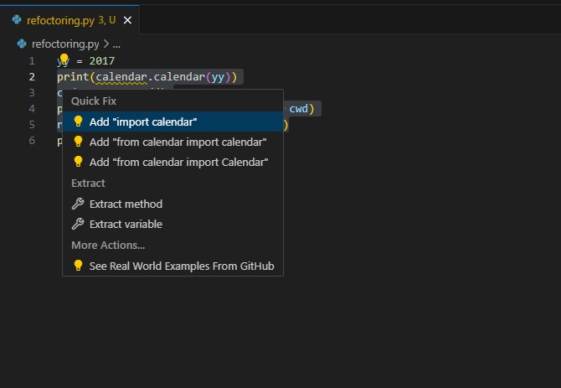

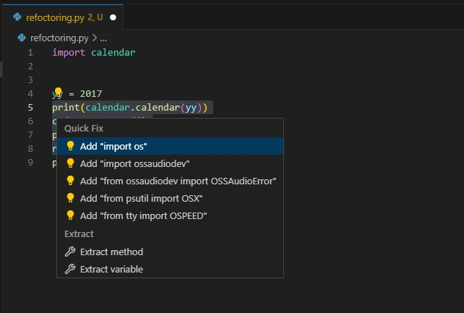

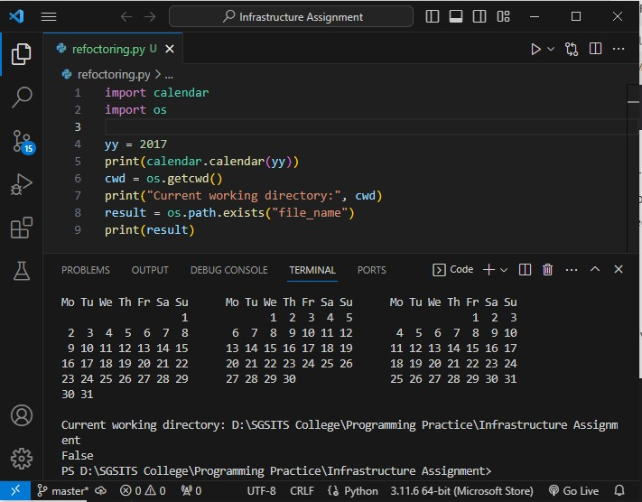

4. Compile the given code and check whether output of the following program is correct or not, if

not debug it using any other editor and correct the code accordingly.

color = ['red', 'blue', 'green', 'pink']

print(color[len(color)])

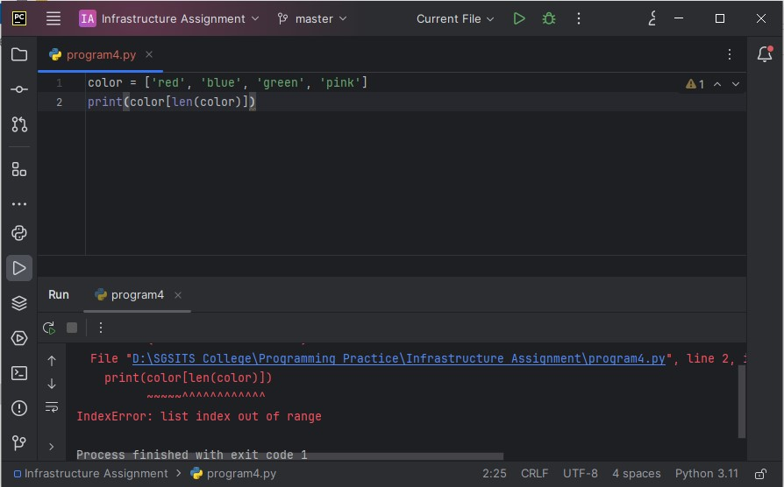

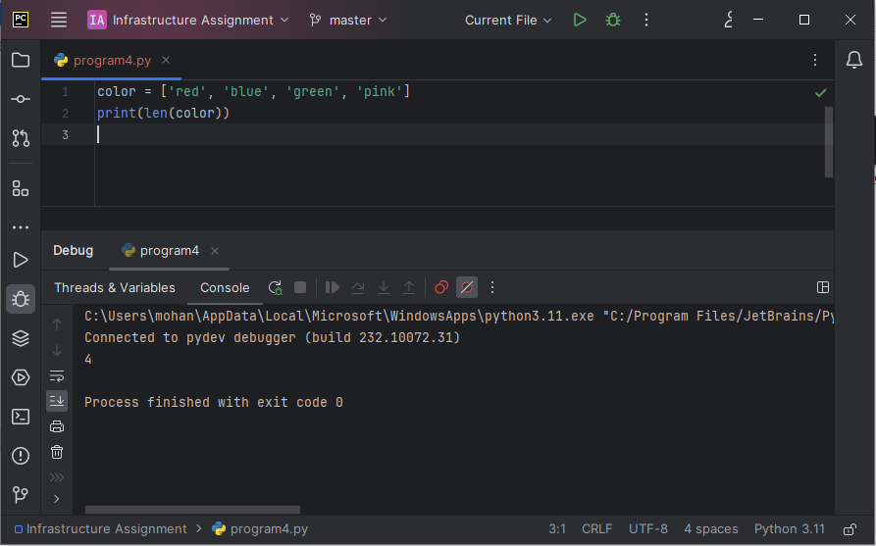

**Linux Assignment**

Que 1 Which command is used to count words and line in a text file attach a screenshot which displaying the word and line count.

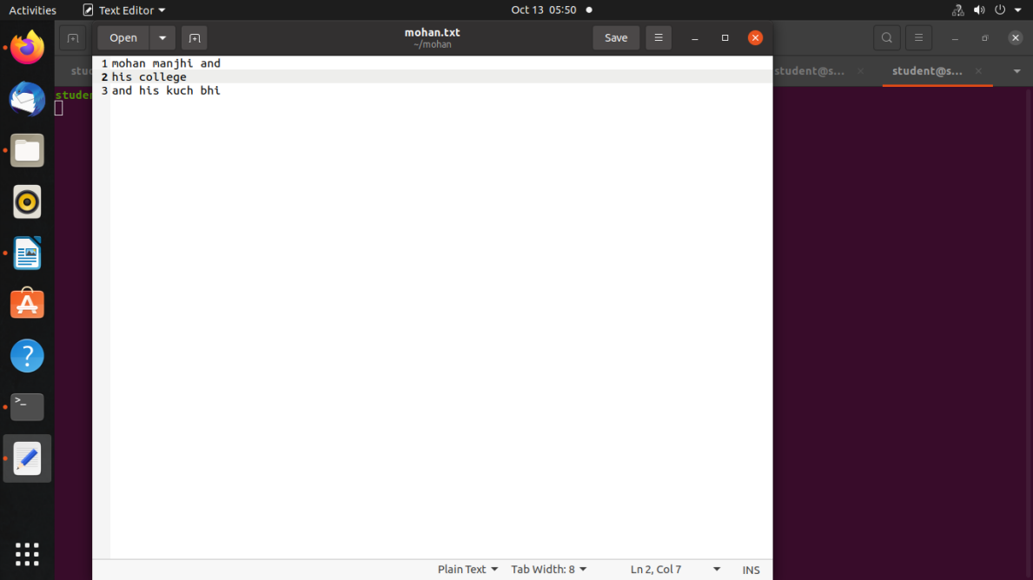

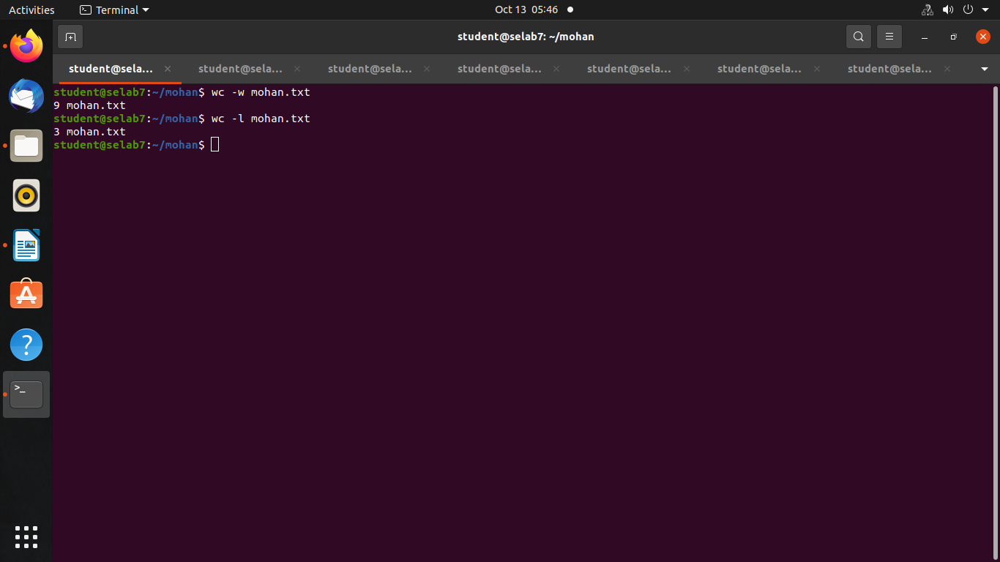

Que 2 Which command is used to search for specific text within a file includes a screenshot showing the result of the search.

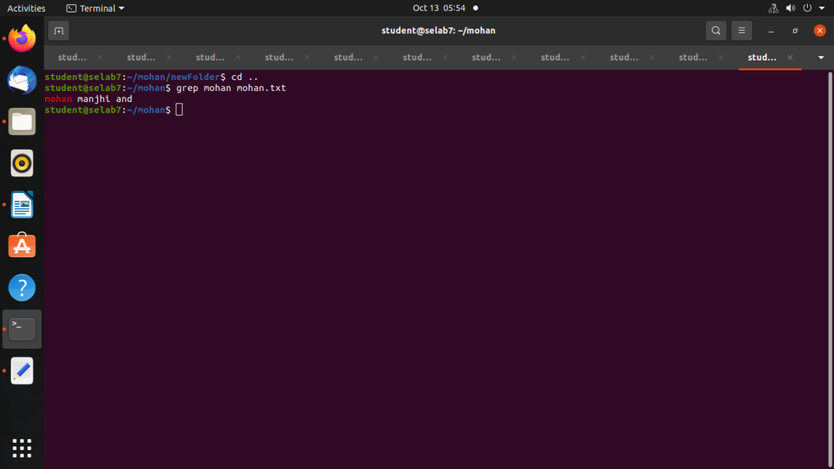

Que 3 Create a new empty file using command and capture a screenshot showing the successful creation of a file.

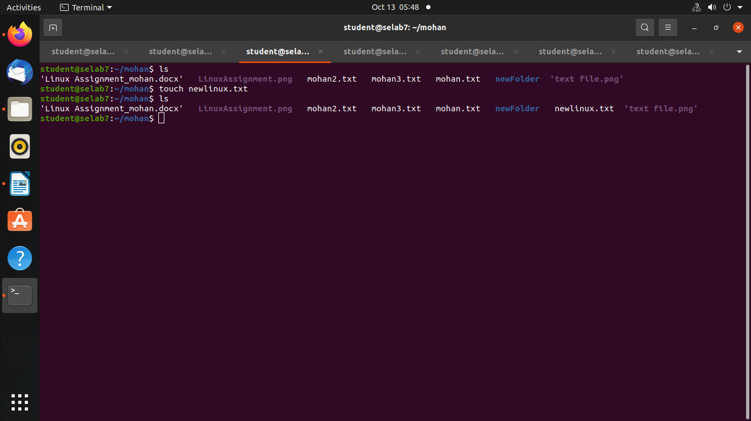

Que 4 Delete a file and remove a directory include screenshots for both actions.

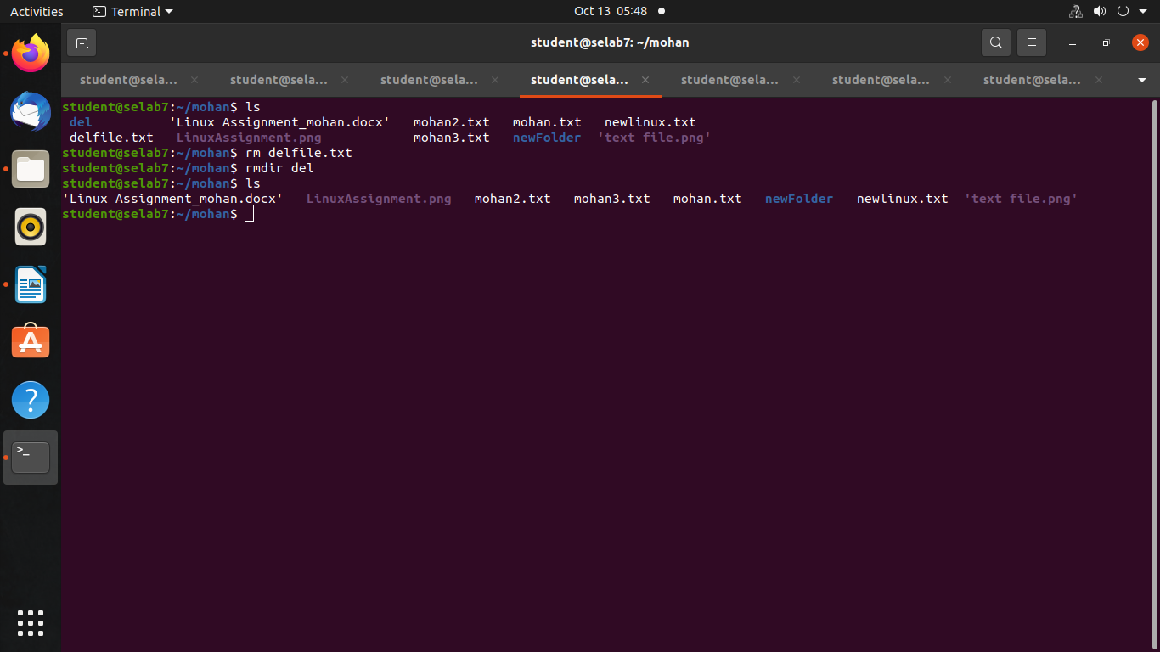

Que 5 Execute the command which display the contents of a file captures a screenshot showing the text.

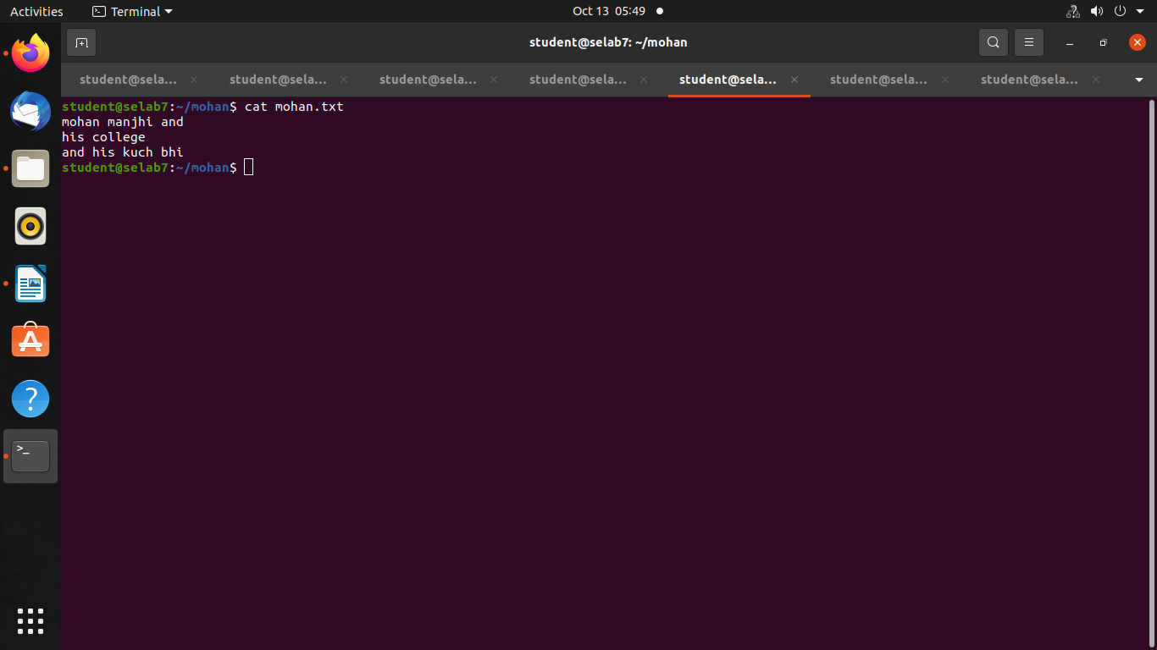

Que 6 Execute the command to navigate to a directory of your choice and take a screenshot of the terminal.

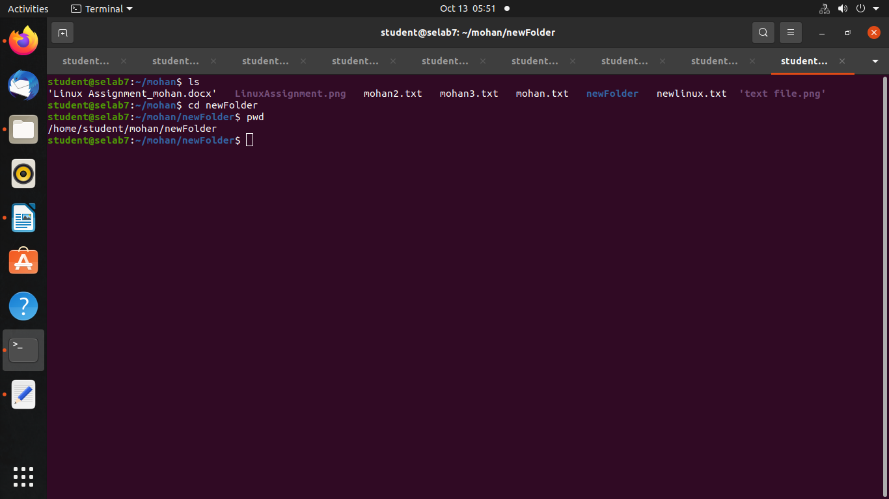

Que 7 Execute the command in your terminal displaying the list of files and directories in your current location.

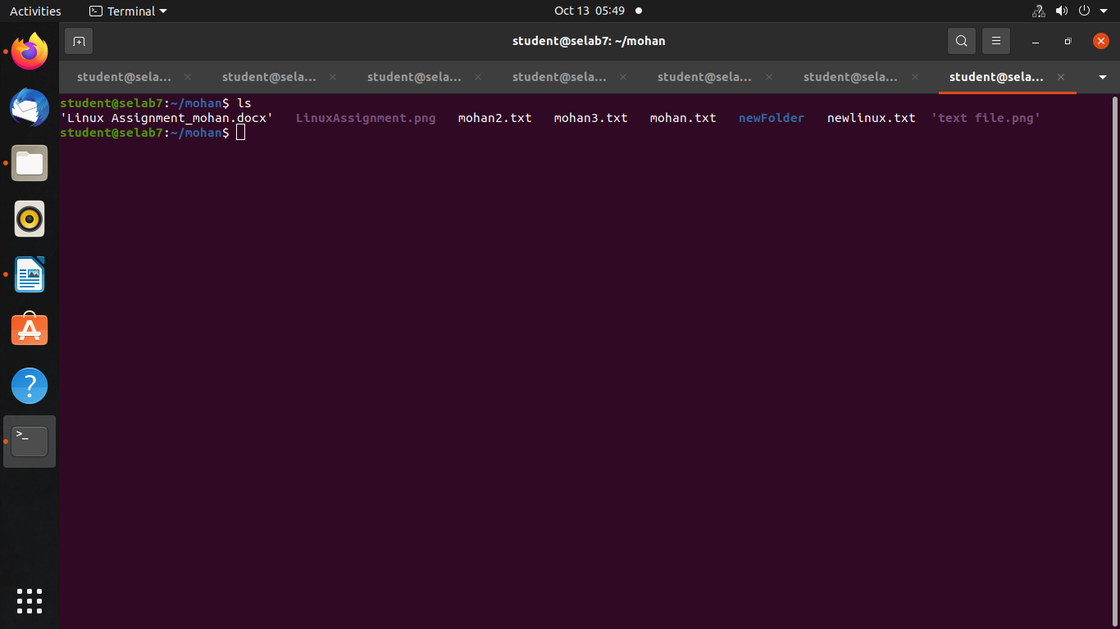

Displaying Directories using “ ll “ commannd

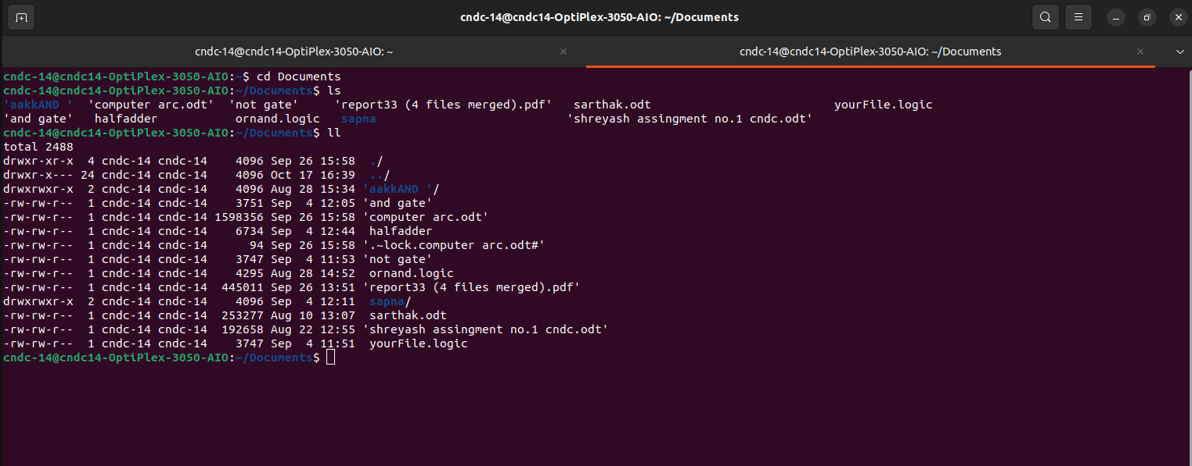

**\* Movie Ticket Booking \***

**Mini Project in C**

**Mini Project Overview**

**Project Title:**  Movie Ticket Booking System in C

**Intruduction :**

- The Movie Ticket Booking System in C is a command line application written in c.

- It allows to users to Book movie ticket and Allow to admin check ticket booking.

**Project Description:**

Simple Movie Ticket Booking project is based on the concept of booking movie tickets.

There’s no login system available for this project, the user can freely use its feature. This mini project contains limited features, but the essential one.

Talking about the features of this Simple project, the user can book movie tickets. For this, the user

has to select a movie name, enter customer details such as name and phone number.

Then the user has to enter seat number. After this, the booking is done. The Admin can also change

the ticket price and view reservations by entering the admin password.

The last feature of this project is about canceling the tickets which can be done by entering the

booking id.

The system does not create an external file to store the user’s data permanently. This system is in

C Programming Language and different variables, strings have been used for the development of it.

The admin password is : mohan

Features:

1. Booking tickets

2. Cancel tickets

3. Change ticket price

4. View all booking records

**Source Code**

#include<stdio.h>

#include<stdlib.h>

#include<strings.h>

#include<string.h>

struct moviedetails{

char name[25];

char phone[15];

int seat;

int id;

};

int changeprize(int);

void reservation(int *,int,int );

int choice1(void);

void cancel(int *);

void ticket1(int choice,char name[10],int id2,int price);

void ticket2(int choice,char name[10],int id2,int price);

void ticket3(int choice,char name[10],int id2,int price);

int cmovie(void);

int movie(void);

void details(void);

struct moviedetails person[300];

int count=0;

int id2=1000;

int main()

{

int **seat,choice,price=500,slection,i;

seat=(int **)calloc(101,sizeof(int *));

for (i=0;i<3;i++)

*(seat+i)=(int *)calloc(101,sizeof(int ));

int x;

while(x!=5)

{

choice=choice1();

switch(choice)

{

case 1:

price=changeprize(price);

break;

case 2:

details();

break;

case 3:

slection=movie();

reservation(seat[slection-1],price,slection);

count++;

break;

case 4:

slection=cmovie();

cancel(seat[slection-1]);

break;

case 5:

x=5;

break;

default:

printf("Choice not available\n");

break;

}

}

}

int changeprize(int prize)

{

char pass[10],pak[10]="mohan";

printf("Enter the password to change price of ticket: ");

scanf("%s",&pass);

if (strcmp(pass,pak)==0)

{

printf("Please enter new price: ");

scanf("%d",&prize);

system("PAUSE");

system("CLS");

}

else

printf("The entered password is wrong! ");

return prize;

}

void reservation(int *array,int price,int slection)

{

int i,j;

printf("\n SCREEN\n\n\n");

for (i=1;i<=100;i++)

{

if (array[i]==0)

printf("%d\t",i);

else

printf("*\t",i);

if(i%10==0)

printf("\n\n");

}

printf("Please enter your name: ");

scanf(" %19[^\n]%*[^\n]",&person[count].name);

printf("Please enter your phone number: ");

scanf("%u",&person[count].phone);

printf("Which seat number you want? ");

scanf("%d",&j);

if (j>100||j<1)

{

printf("seat1 number is unavailable in this theater\n");

printf("Please re-enter seat number: ");

scanf("%d",&j);

}

if (array[j]==1)

{

printf("Sorry, this ticket is already booked! Please choose another seat.\n");

scanf("%d",&j);

}

else

array[j]=1;

person[count].seat=j;

if (slection==1)

ticket1(j,person[count].name,id2,price);

else if (slection==2)

ticket2(j,person[count].name,id2,price);

else

ticket3(j,person[count].name,id2,price);

id2++;

}

int choice1(void)

{

int choice;

printf(" Simple Movie Ticket Booking System\n");

printf(" ==================================================================\n");

printf("|| 1- To edit price of ticket (only admin): ||\n");

printf("|| 2- To view reserved tickets (only admin): ||\n");

printf("|| 3- To puchase ticket: ||\n");

printf("|| 4- To cancel the seat: ||\n");

printf("|| 5- Exit system: ||\n");

printf("||================================================================||\n");

printf(" Enter your choice: ");

scanf("%d",&choice);

return choice;

}

void cancel(int *array)

{

int Cseat,i,stop;

printf("Please enter ID number of ticket: ");

scanf("%d",&Cseat);

for (i=0;i<300;i++)

{

if(Cseat==person[i].id)

{

stop=5;

system("cls");

printf("%s your seat is %d cancelled",person[i].name,person[i].seat);

array[person[i].seat]=0;

i=300;

}

}

if (stop!=5)

printf("Ticket ID number is incorrect please enter right one to cancel ticket: \n");

}

void details(void)

{

int i;

char pass[10],pak[10]="mohan";

printf("Enter the password to see details: ");

scanf("%s",&pass);

if (strcmp(pass,pak)==0)

{

for (i=0;i<count;i++)

{

printf("seat no: %d is booked by%s booking id

is %d\n",person[i].seat,person[i].name,person[i].id);

}

}

else

printf("Entered password is wrong \n");

system("PAUSE");

system("CLS");

}

int movie(void)

{

int i;

system("cls");

printf("\t\t\twhich movie you want to see?\n");

printf("\t\t\t----------------------------\n\n");

printf("\t\t\tpress 1 for 3 Idiots (Engineering Life)\n\n");

printf("\t\t\tpress 2 for Lakshya \n\n");

printf("\t\t\tpress 3 for Story of Mohan: A Engineer Student\n");

scanf("%d",&i);

system("cls");

return i;

}

int cmovie(void)

{

int i;

printf("\t\t\twhich movie ticket you want to cancel\n");

printf("\t\t\t-------------------------------------\n");

printf("\t\t\tpress 1 for 3 Idiots (Engineering Life)\n\n");

printf("\t\t\tpress 2 for Lakshya\n\n");

printf("\t\t\tpress 3 for Mohan: A Engineer Student\n");

scanf("%d",&i);

return i;

}

void ticket1(int choice,char name[10],int id2,int price)

{

system("cls");

printf("\n\n");

printf("\t-----------------THEATER BOOKING TICKET----------------\n");

printf("\t============================================================\n");

printf("\t Booking ID : %d \t\t\tShow Name : 3 Idiots (Engineering Life)\n",id2);

printf("\t Customer : %s\n",name);

printf("\t\t\t Date : 29-04-2019\n");

printf("\t Time : 08:00pm\n");

printf("\t Hall : 02\n");

printf("\t seats No. : %d \n",choice);

printf("\t price . : %d \n\n",price);

person[count].id=id2;

printf("\t============================================================\n");

return;

}

void ticket2(int choice,char name[10],int id2,int price)

{

system("cls");

printf("\n\n");

printf("\t-----------------THEATER BOOKING TICKET----------------\n");

printf("\t============================================================\n");

printf("\t Booking ID : %d \t\t\tShow Name : Lakshya\n",id2);

printf("\t Customer : %s\n",name);

printf("\t\t\t Date : 15-04-2019\n");

printf("\t Time : 09:00pm\n");

printf("\t Hall : 03\n");

printf("\t seats No. : %d \n",choice);

printf("\t price . : %d \n\n",price);

person[count].id=id2;

printf("\t============================================================\n");

return;

}

void ticket3(int choice,char name[10],int id2,int price)

{

system("cls");

printf("\n\n");

printf("\t-----------------THEATER BOOKING TICKET----------------\n");

printf("\t============================================================\n");

printf("\t Booking ID : %d \t\t\tShow Name : Mohan: A Engineer Student \n",id2);

printf("\t Customer : %s\n",name);

printf("\t\t\t Date : 5-07-2019\n");

printf("\t Time : 10:00pm\n");

printf("\t Hall : 04\n");

printf("\t seats No. : %d \n",choice);

printf("\t price . : %d \n\n",price);

person[count].id=id2;

printf("\t============================================================\n");

return;

}